

**Information Technology Institute**

**Digital Design and Computer Architecture**

**RISC-V: From Single-Cycle to Pipelined Implementation**

*Project implemented and documented by Ali Yehia*

*Under supervision of Prof. Hesham Omran*

Contents

1. RISC-V Single Cycle Architecture 3

1.1 Data Path 3

1.1.1 Mux2x1 4

1.1.2 PC 4

1.1.3 Add 5

1.1.4 Register File 5

1.1.5 Immediate Generator 6

1.1.6 Branch Comparator 6

1.1.7 ALU 7

1.1.8 Mux3x1 8

1.2 RISC-V Datahpath 9

1.3 RISC-V Control Logic 12

1.3.1 R-Format 0

1.3.2 I-Format 1

1.3.3 S-Format 1

1.3.4 B-Format 2

1.3.5 U-Format 2

1.3.6 J-Format 2

1.4 RISC-V Single Cycle Top Module 3

1.5 Memories 5

1.5.1 Instruction Memory 5

1.5.2 Data Memory 5

2. Generating Fibonacci Machine Code for RISC-V using Venus 7

2.1 Fibonacci Sequence Assembly Code 7

3. Verification of RISC-V RTL 10

3.1 RISC-V Simple Testbench 10

3.2 Simulation Results 11

3.2.1 Testing Rest of the Instructions (store word) 11

4. Pipelined RISC-V Archtiecture 13

4.1 Pipeline Hazards 17

4.1.1 Data Hazards 17

4.1.2 Control Hazards 17

4.1.3 Structural Hazards 17

4.2 Implementation of Pipelined RISC-V Without Hazard Unit: Fixing Hazards by Stalling 19

4.3 Simulation Results with Stalling 20

4.4 Implementation of Pipelined RISC-V With Hazard Unit 21

4.4.1 Handling Data Hazards via Forwarding 21

4.4.2 Resolving Load Hazards 25

4.5 Modified RTL for Pipelined RISC-V 27

4.5.1 Enabled Register 27

4.5.2 PC 27

4.5.3 Datapath 28

4.5.4 Control Logic 32

4.5.5 Hazard Unit 33

4.6 Simulation Results of Pipelined RISC-V with Hazard Unit 34

5. References 35

# RISC-V Single Cycle Architecture

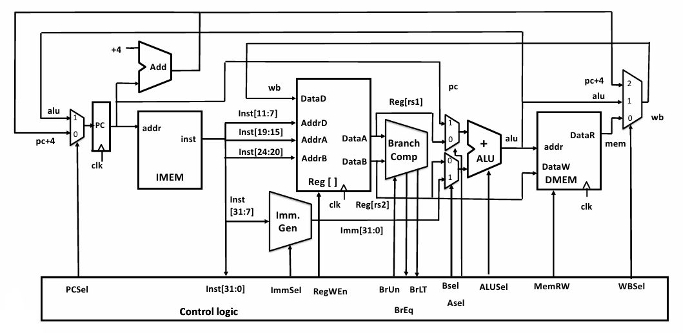

Figure ‎1‑1: RISC-V single cycle. **[1]**

## Data Path

Data Path



Figure ‎1‑2: RISC-V datapath. Adapted from **[1]**

### Mux2x1

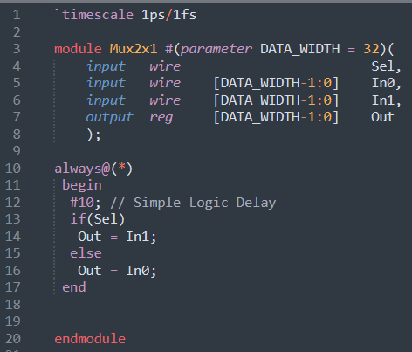

### PC

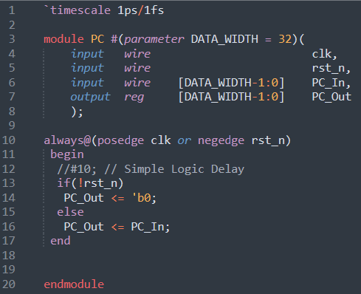

### Add

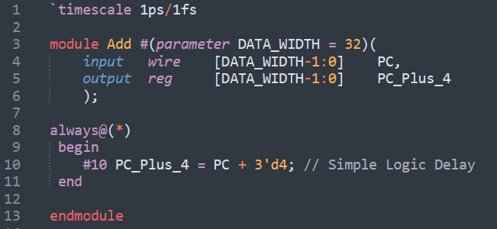

### Register File

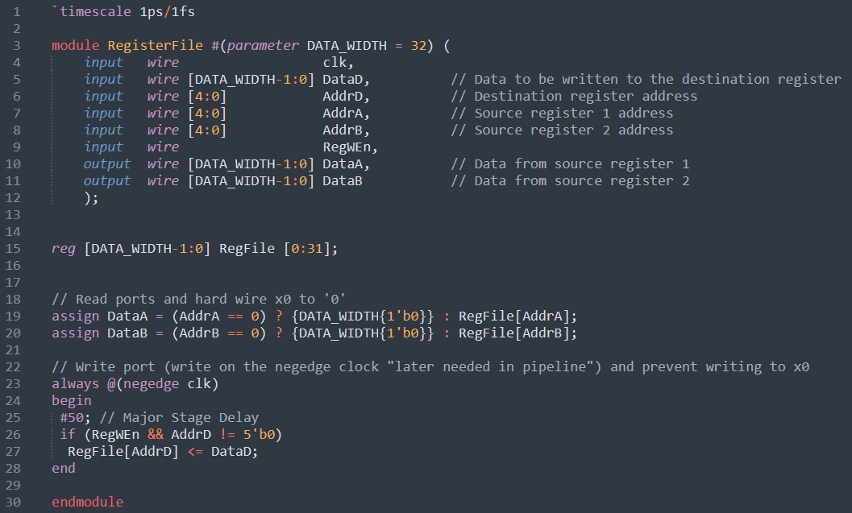

### Immediate Generator

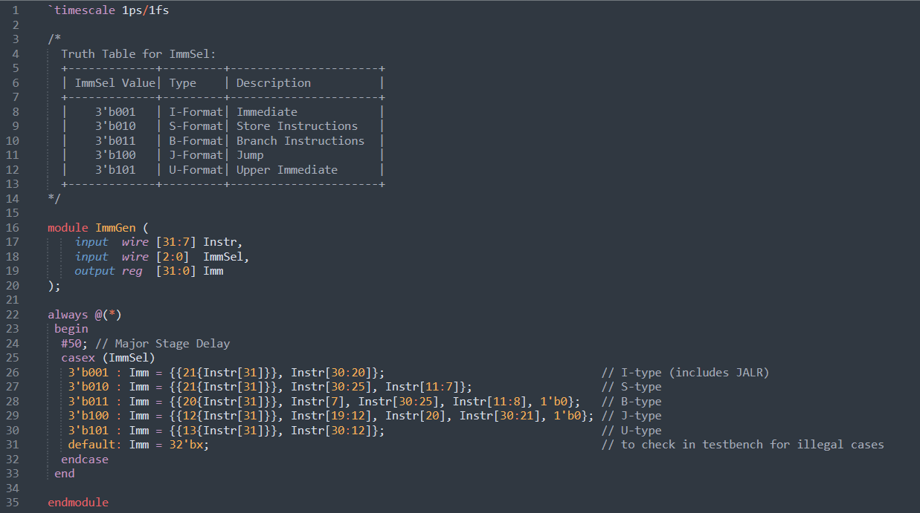

### Branch Comparator

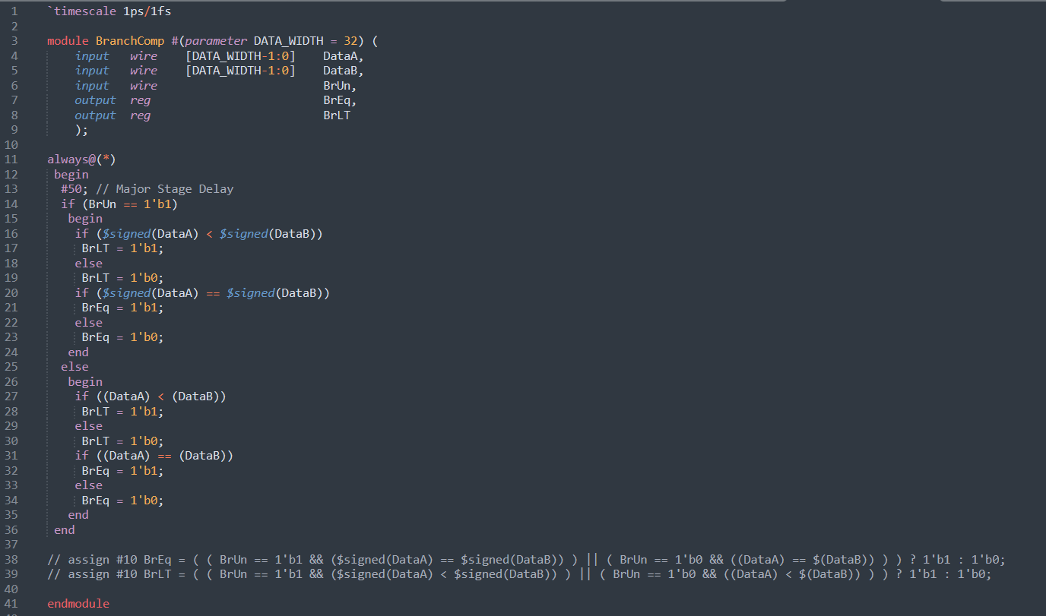

### ALU

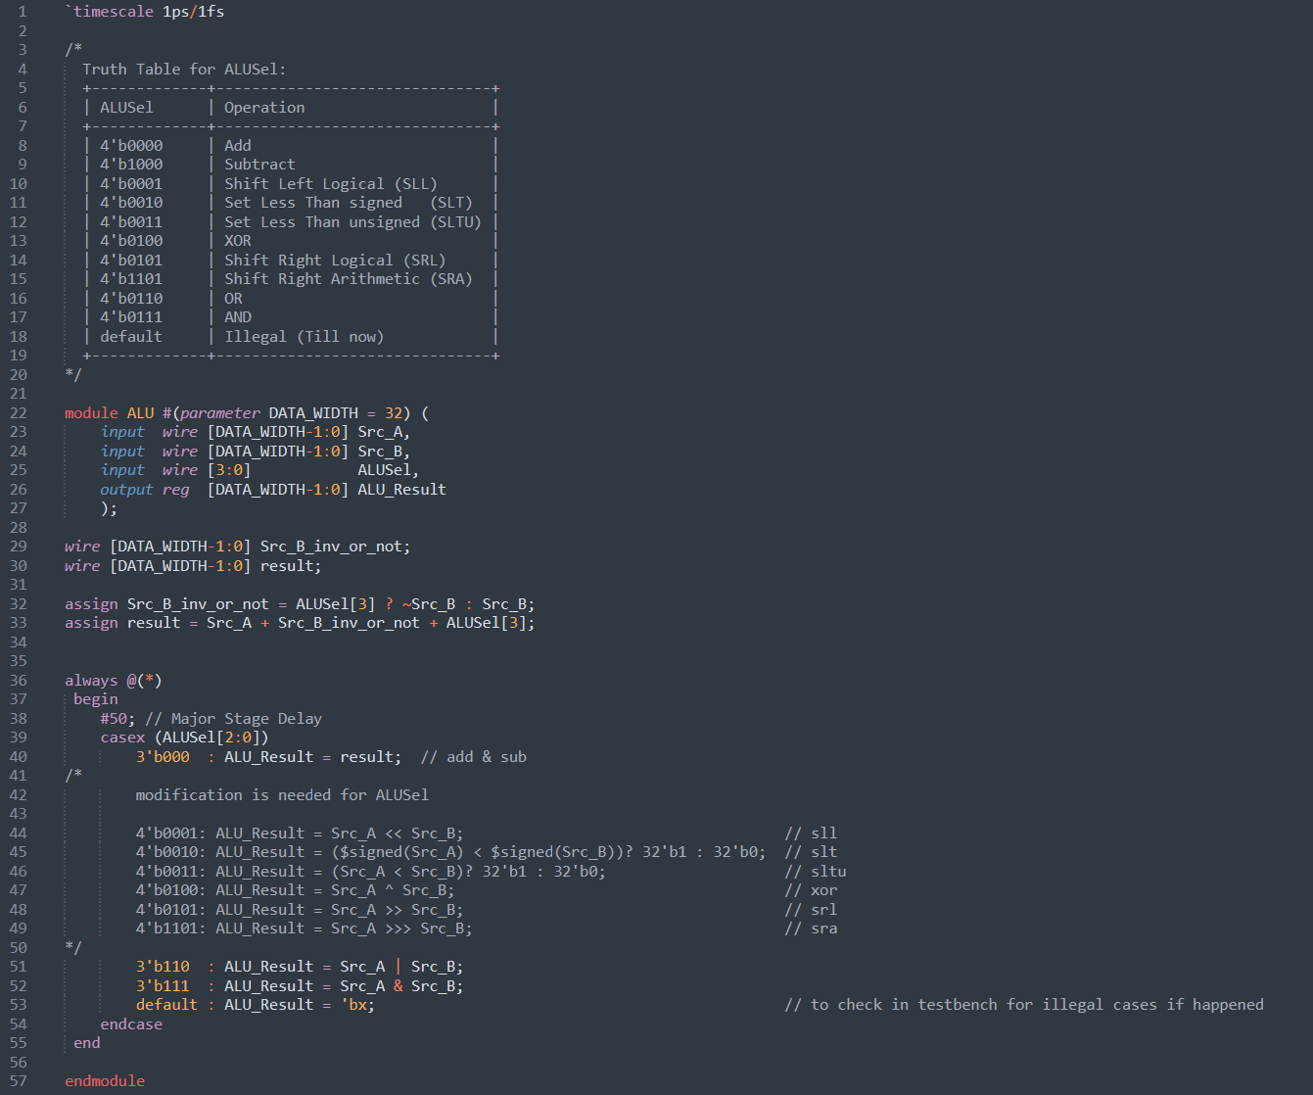

### Mux3x1

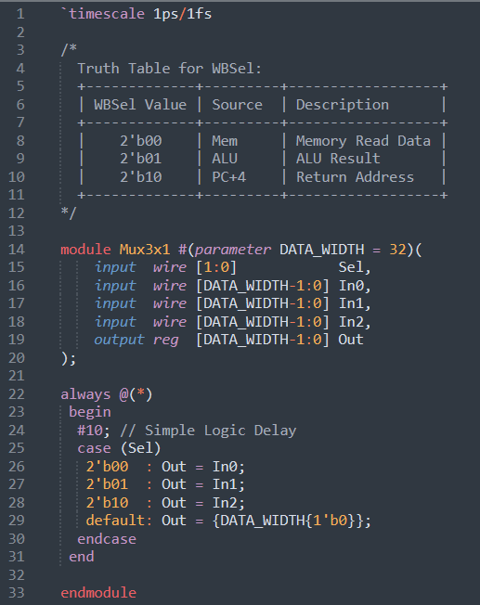

## RISC-V Datahpath

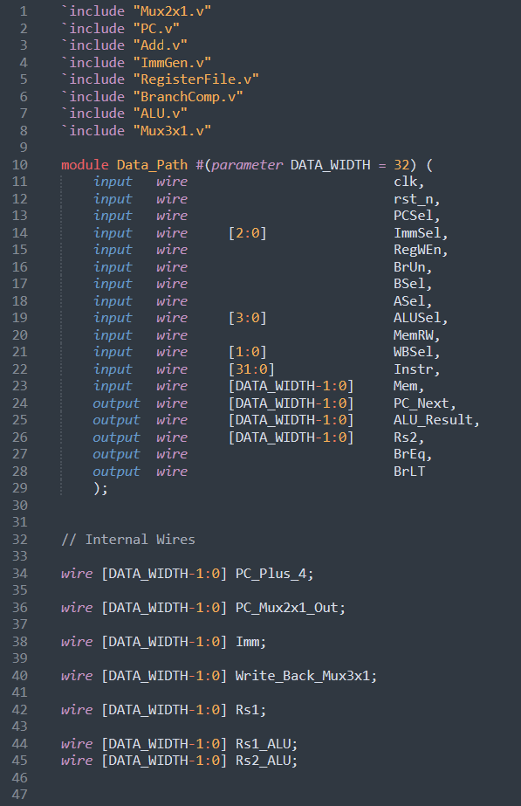

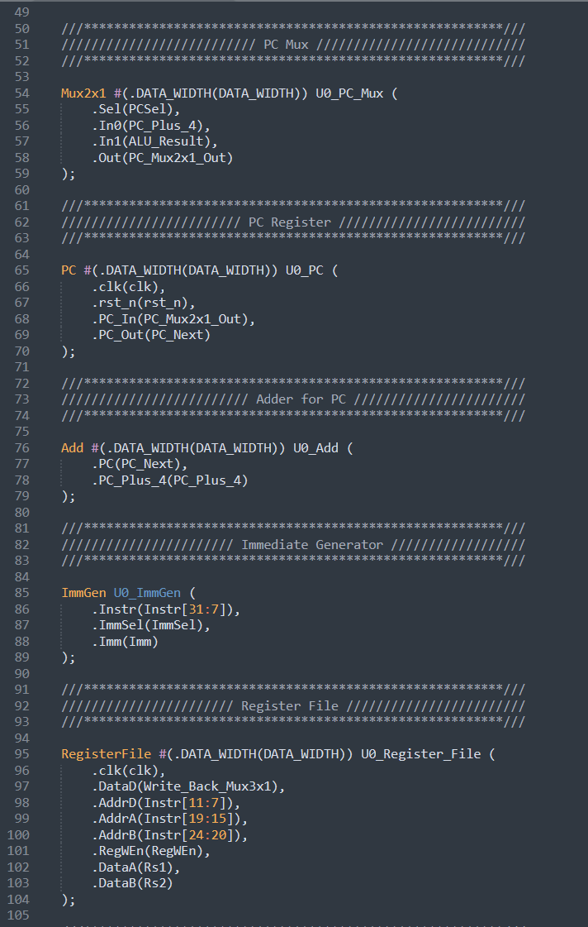

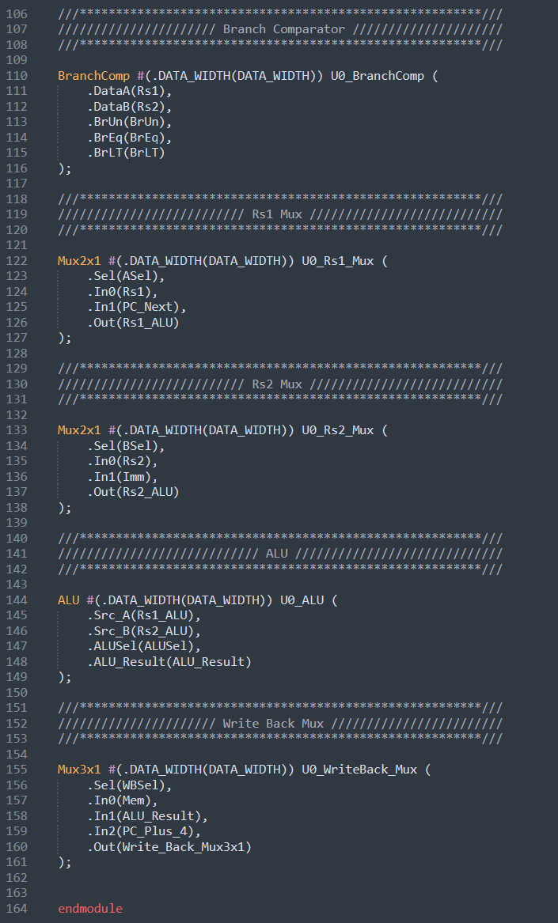

## RISC-V Control Logic

**Control Logic Implementation**

Only 9 bits are needed to decode the 6 RISC-V instruction formats and their corresponding functions as shown in the figure below.

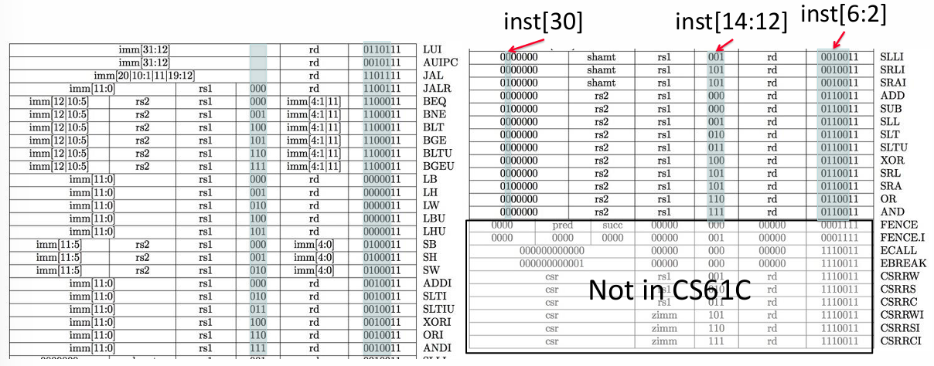

Figure ‎1‑3: RV321 is a 9-bit ISA. **[1]**

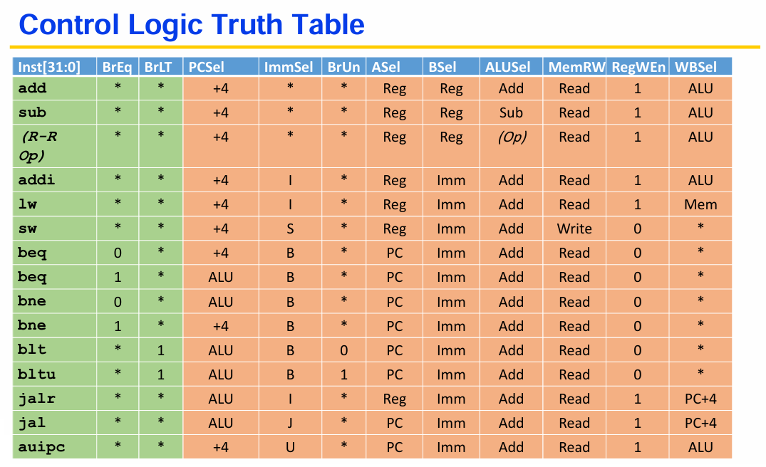

(1)

(1)

(1)

(1)

(0)

(2)

(2)

(1)

(0)

(0)

(0)

(1)

(1)

(1)

(1)

(1)

(1)

(1)

(1)

(1)

(1)

(1)

(1)

(1)

(1)

(2)

(3)

(3)

(3)

(3)

(3)

(1)

(4)

(5)

(3)

(0)

(0)

(0)

(0)

(0)

(1)

(0)

(0)

(0)

(0)

(0)

(0)

(0)

(0)

(0)

(0)

(1)

(x)

(0)

(0)

(0)

(0)

(0)

(0)

(0)

(0)

(0)

(0)

(0)

(0)

(0)

(0)

(0)

(0)

(0)

(0)

(1)

(1)

(1)

(1)

(1)

(0)

(1)

(1)

(1)

(0)

(0)

(0)

(0)

(0)

(0)

(0)

(1)

(1)

(1)

(1)

(1)

(1)

(0)

(0)

Figure ‎1‑4: Control logic truth table. Adapted from **[1]**

For PCSel: 0 = PC+4, 1 = ALU

For ASel: 0 = Reg, 1 = PC

For BSel: 0 = Reg, 1 = Imm

For WBSel: 0 = Mem, 1 = ALU, 10 (Binary) = PC+4

**Control Logic Module**

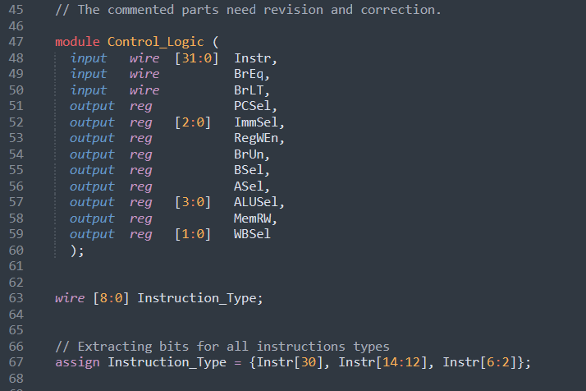

### R-Format

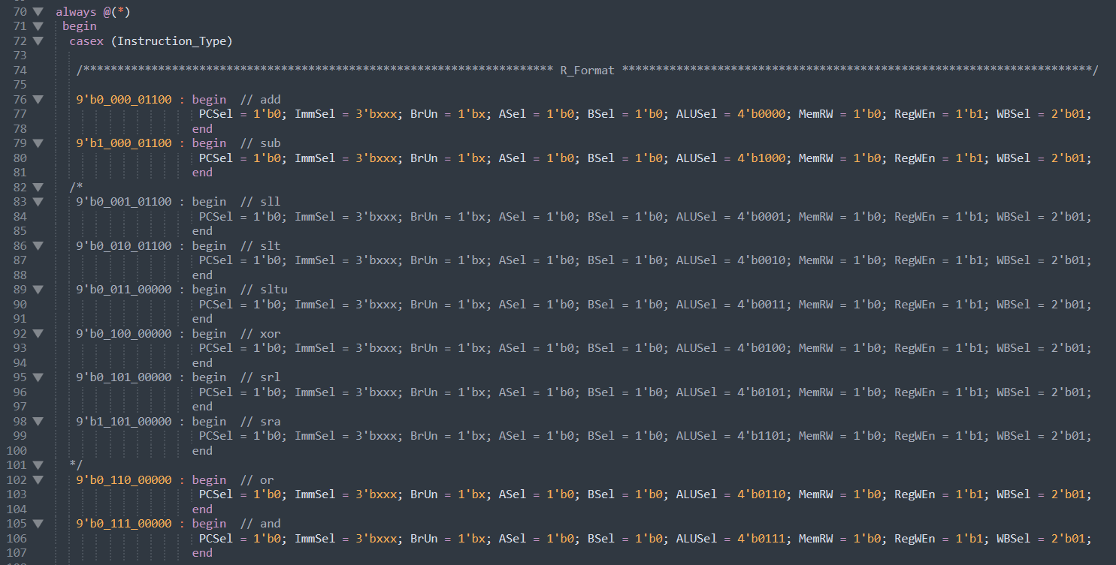

### I-Format

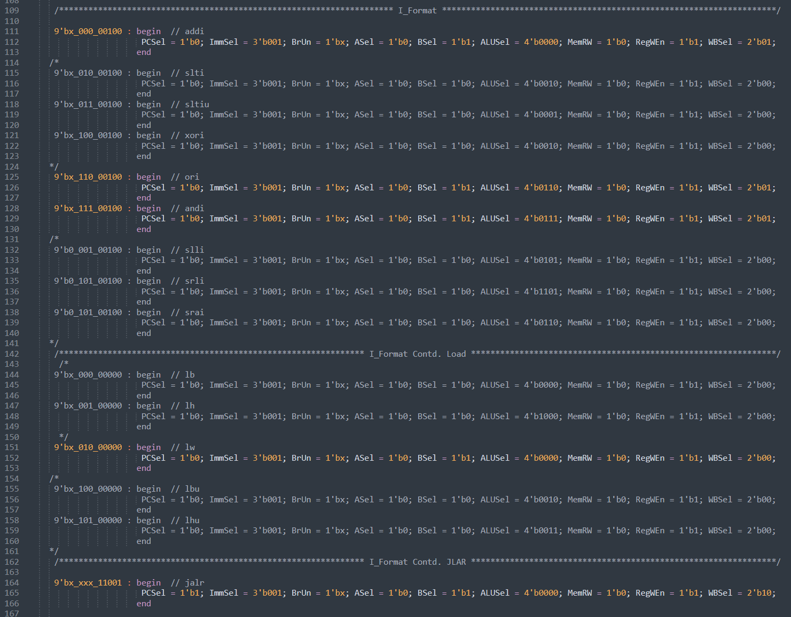

### S-Format

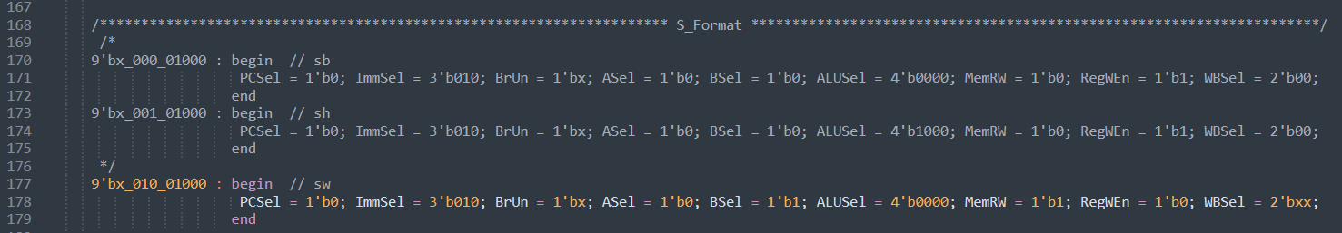

### B-Format

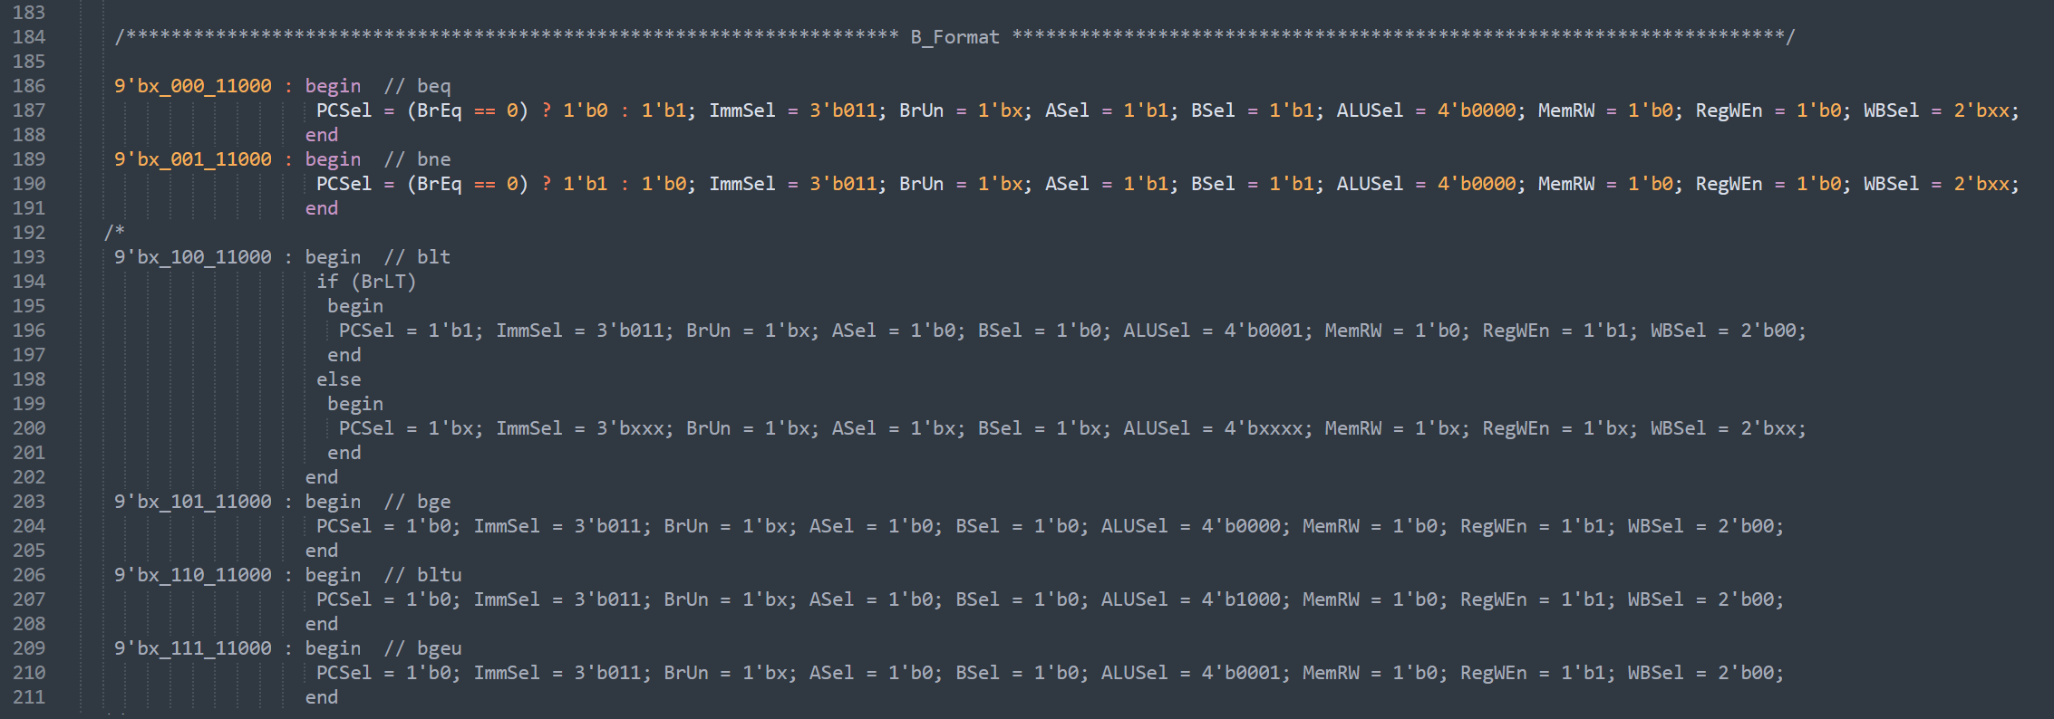

### U-Format

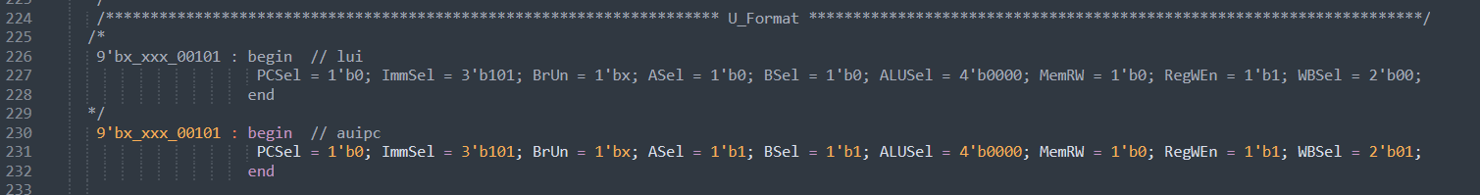

### J-Format

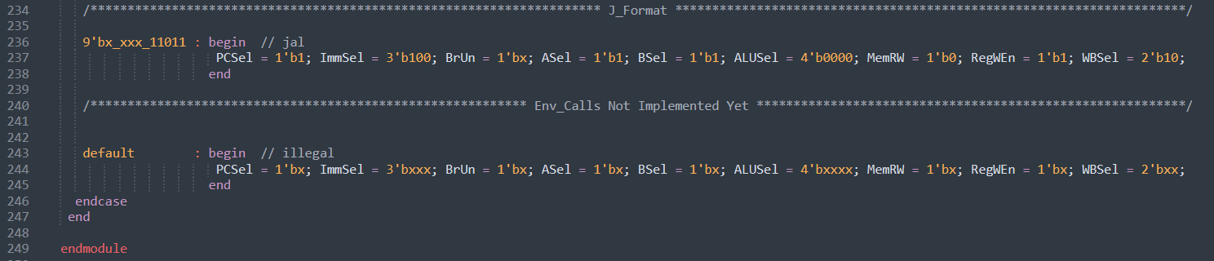

## RISC-V Single Cycle Top Module

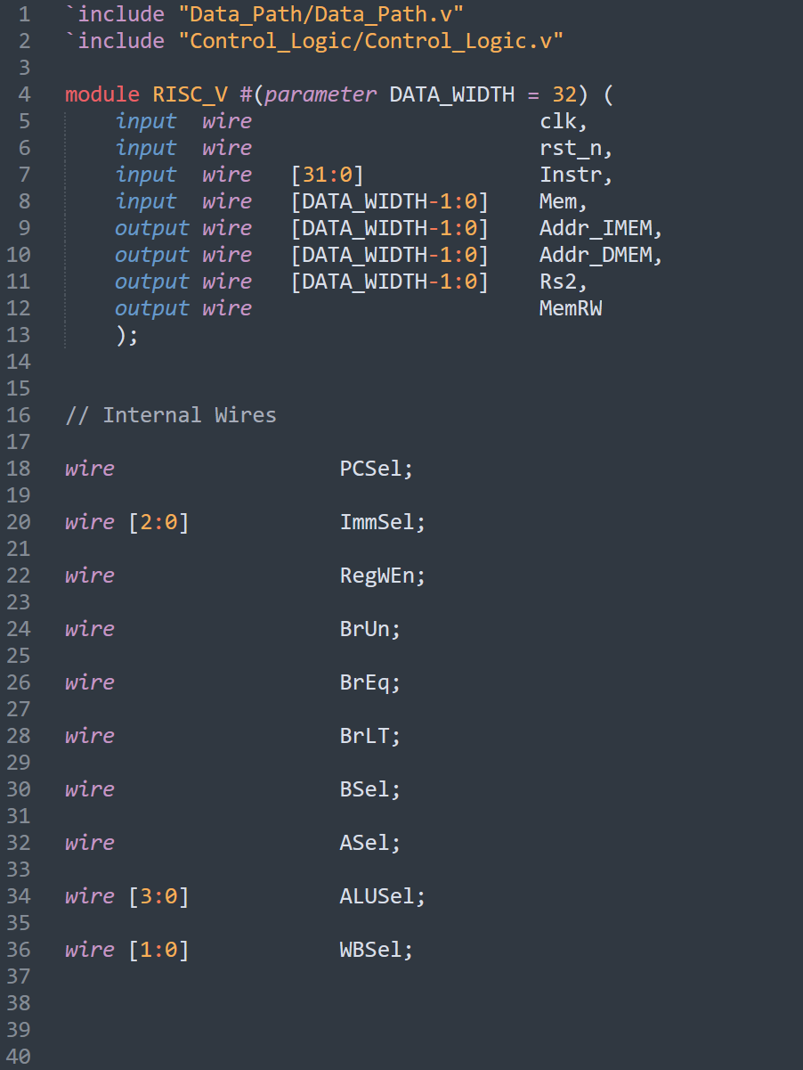

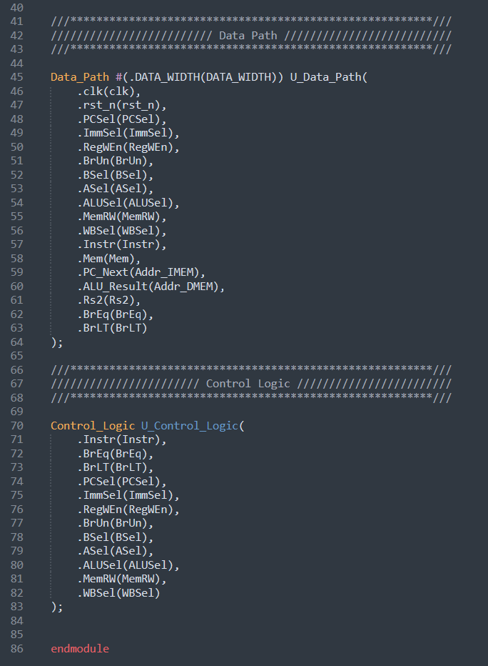

## Memories

DMEM and IMEM were implemented for behavioral modeling purposes since they come as hard macros. These implementations interact directly with the processor without incorporating any cache-specific operations, such as hit or miss behavior, which involves managing tags, priorities, and exception handling.

### Instruction Memory

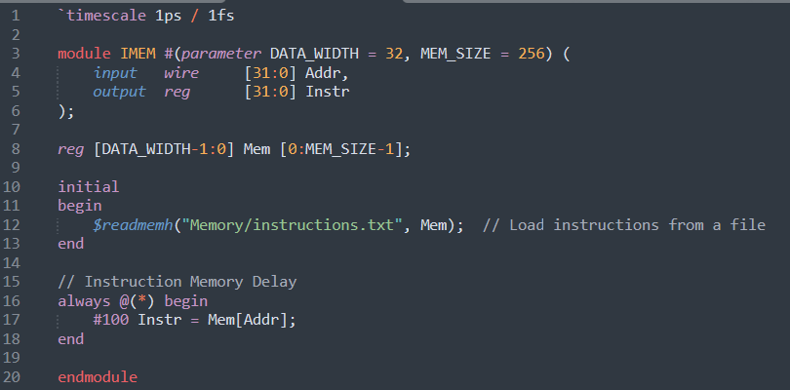

### Data Memory

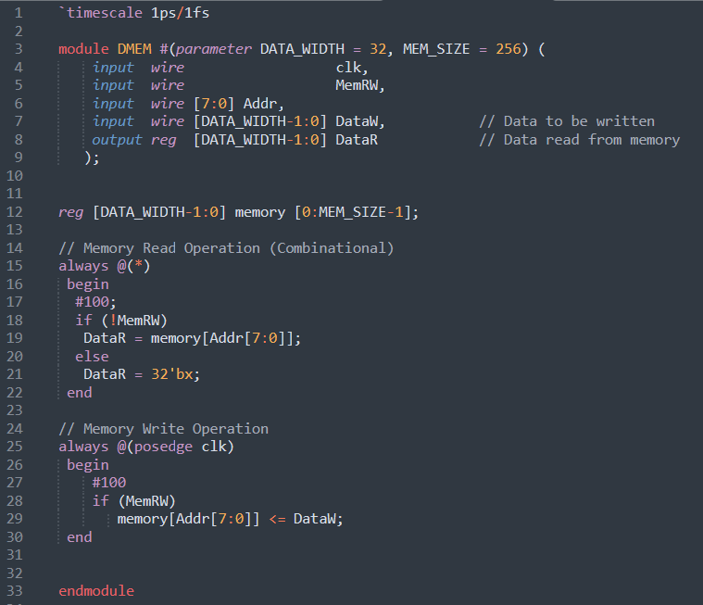

**NOTE:**

For simplicity, assume that the instruction memory is a 1kB word-addressable ROM and the data memory is a 1kB word-addressable RAM, i.e., you will only connect bits 9 to 2 in the address bus.

You have a **32-bit address**, but your memory only has **256-word locations (1kB)**. So, the question is: how can a memory with only 256 locations handle addresses that span a much larger range (like 0x10000000) , as seen in the Venus simulator?

**The Solution**

The system **ignores most of the address bits** and only uses the bits that fit within the memory size. Specifically:

* Only **bits 9 to 2** of the address are used to index the memory.
* The remaining bits (31 to 10 and 1 to 0) are **ignored**.

**How It Works**

1. **Word Addressing**:  
   Since the memory is **word-addressable**, each location holds 4 bytes. The **lower 2 bits** (1 and 0) of the address are not needed because they represent the byte offset within a word. For example:
   * Address 0x00000000 → Word 0, Byte 0.
   * Address 0x00000004 → Word 1, Byte 0.
   * Address 0x00000008 → Word 2, Byte 0

**Example with 0x10000000**

If you have an address like 0x10000000:

* In binary: 00010000000000000000000000000000
* Take bits 9 to 2: 00000000
* Result: This address maps to **word 0 in memory**.

If you instead have 0x10000004:

* In binary: 00010000000000000000000000000100
* Take bits 9 to 2: 00000001
* Result: This address maps to **word 1 in memory**.

# Generating Fibonacci Machine Code for RISC-V using Venus

## Fibonacci Sequence Assembly Code

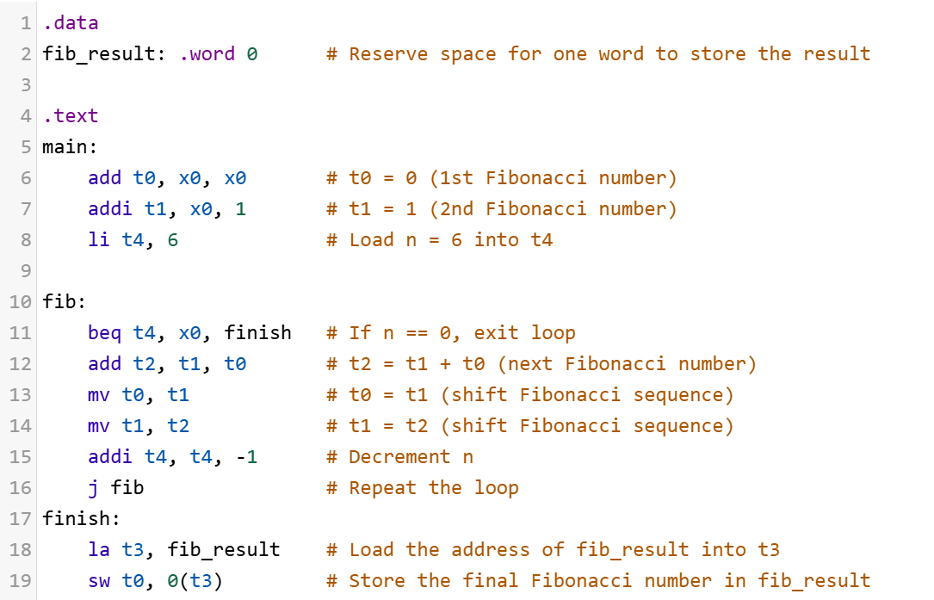

Figure ‎2‑1: Fibonacci Assembly Code for the 6th Fibonacci Number.



Figure ‎2‑2: 6th Fibonacci number is stored at register x5.

The address of fib_result is calculated during the la t3, fib_result instruction. If any instruction is inserted before this as no operation (nop) as shown in Figure ‎2‑3, the address of fib_result will shift, causing the calculated address to increase. For example, if the address was initially expected to be 0x00010000, adding instructions before the la may result in an address like 0x00010004 instead as in Figure ‎2‑4. This discrepancy would cause the result to no longer align with the expected DMEM address, potentially leading to incorrect behavior.

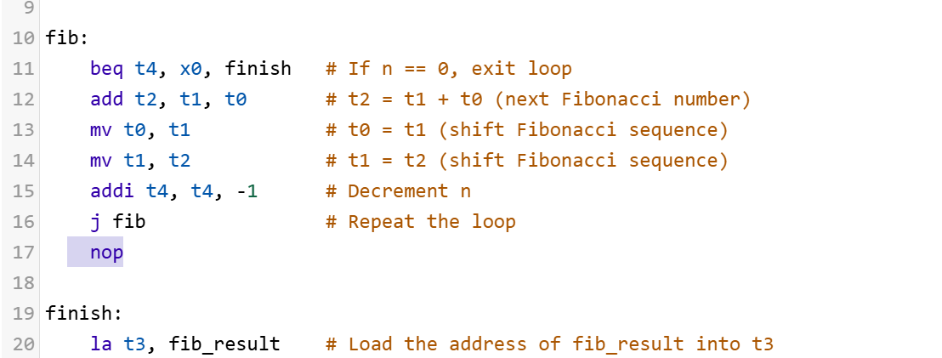

Figure ‎2‑3: Insertion of instruction before loading address of the result.

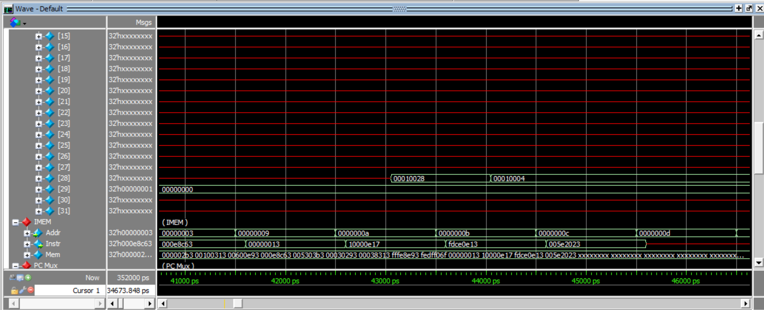

Incorrect address

Figure ‎2‑4: Incorrect mapped addressed.

Unlike the Venus simulator, which directly calculates the address of .word 0 based on the declared memory layout and does not rely on subsequent instruction positioning, in this case, manual adjustments are necessary to ensure consistency with the expected address mapping.

Therefore, adjustments were made to the code by moving the la t3, fib_result instruction to the top. This ensures that its calculated address remains consistent, even if additional instructions are inserted before it later in the code as shown in Figure ‎2‑5.

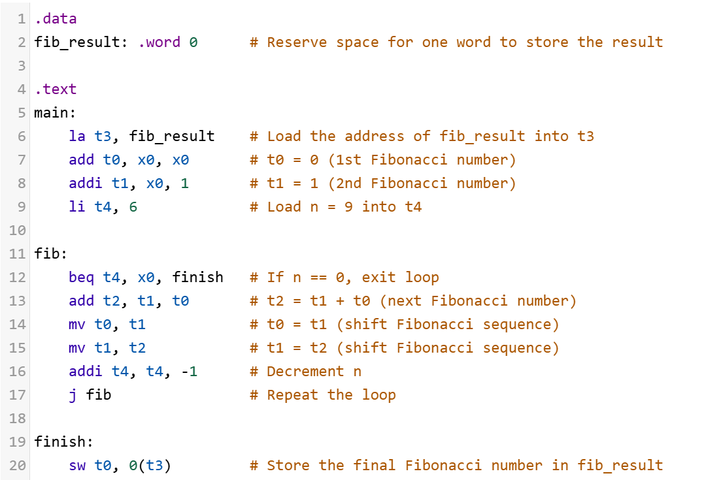

Figure ‎2‑5: Modified assembly code.

# Verification of RISC-V RTL

## RISC-V Simple Testbench

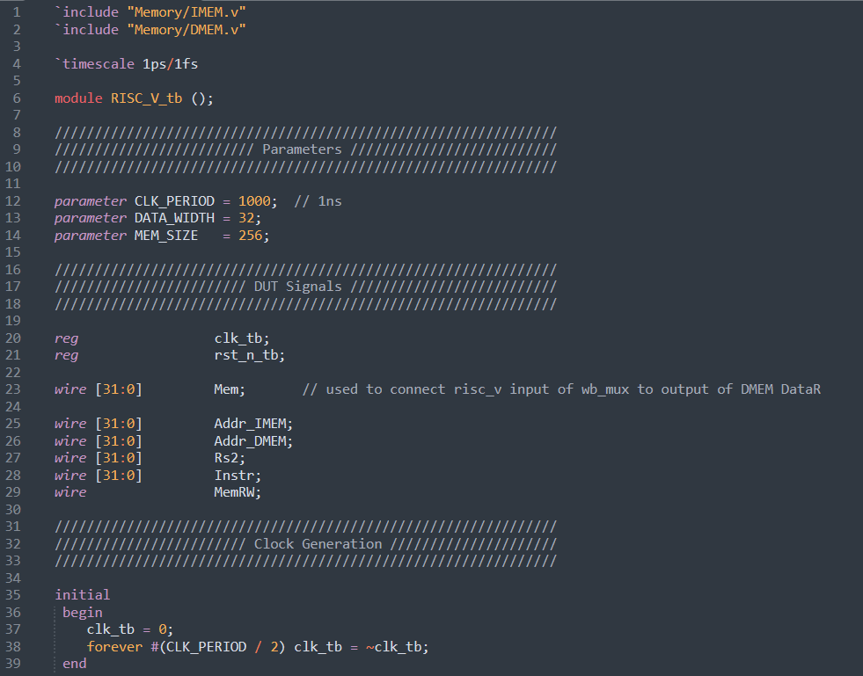

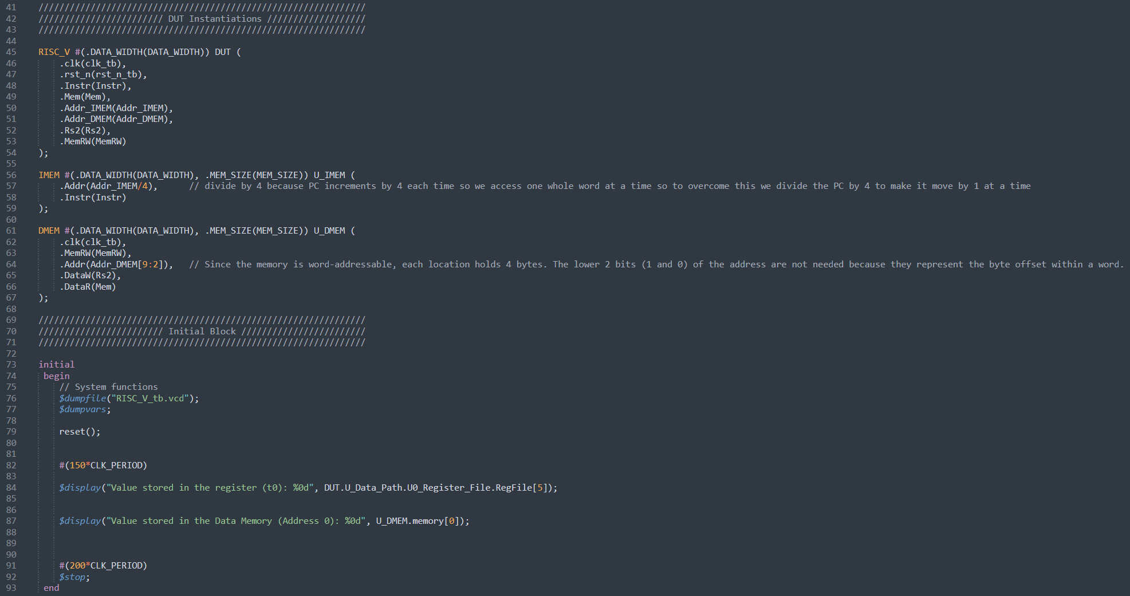

## Simulation Results

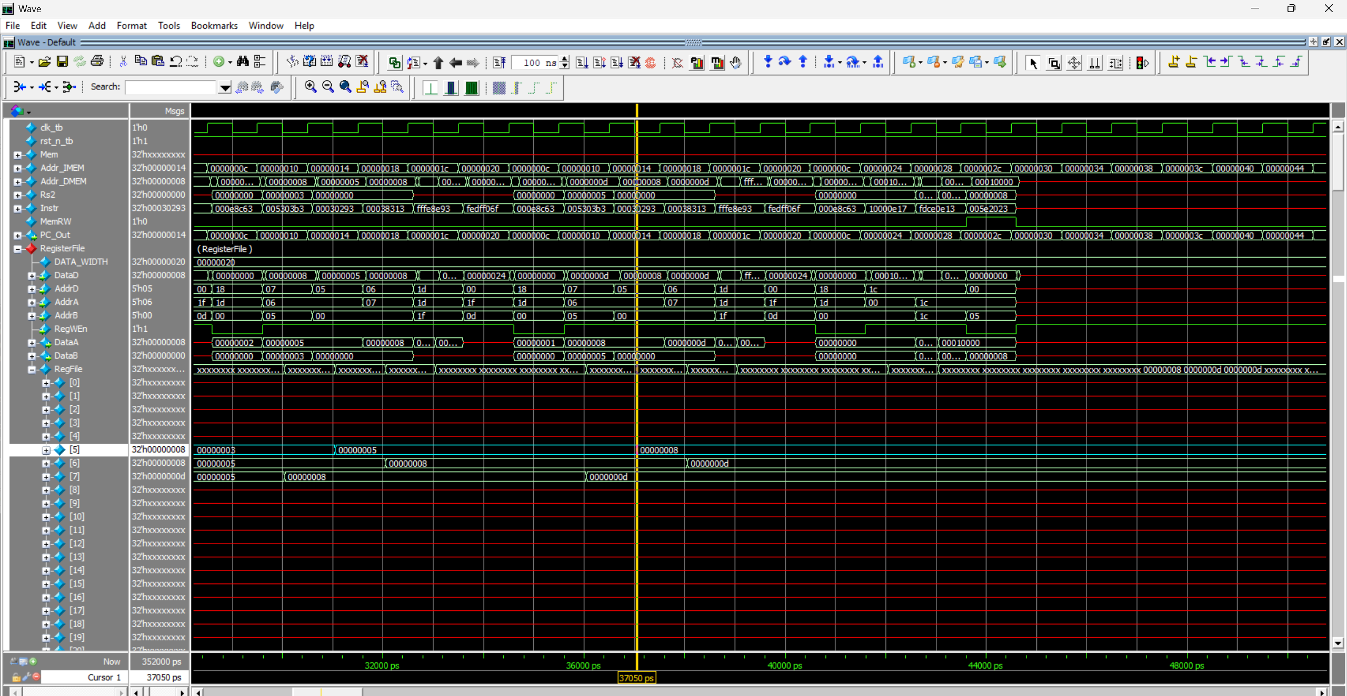

Figure ‎3‑1: 6th Fibonacci number successfully written at register x5.

### Testing Rest of the Instructions (store word)

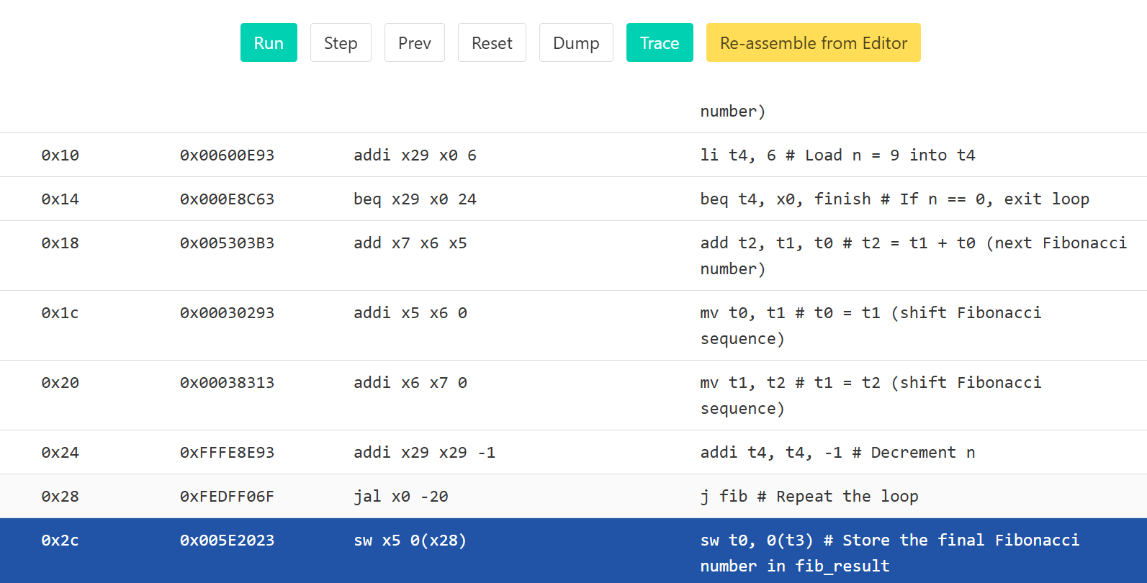

Figure ‎3‑2: 6th Fibonacci number should be stored at PC = 0x2c.

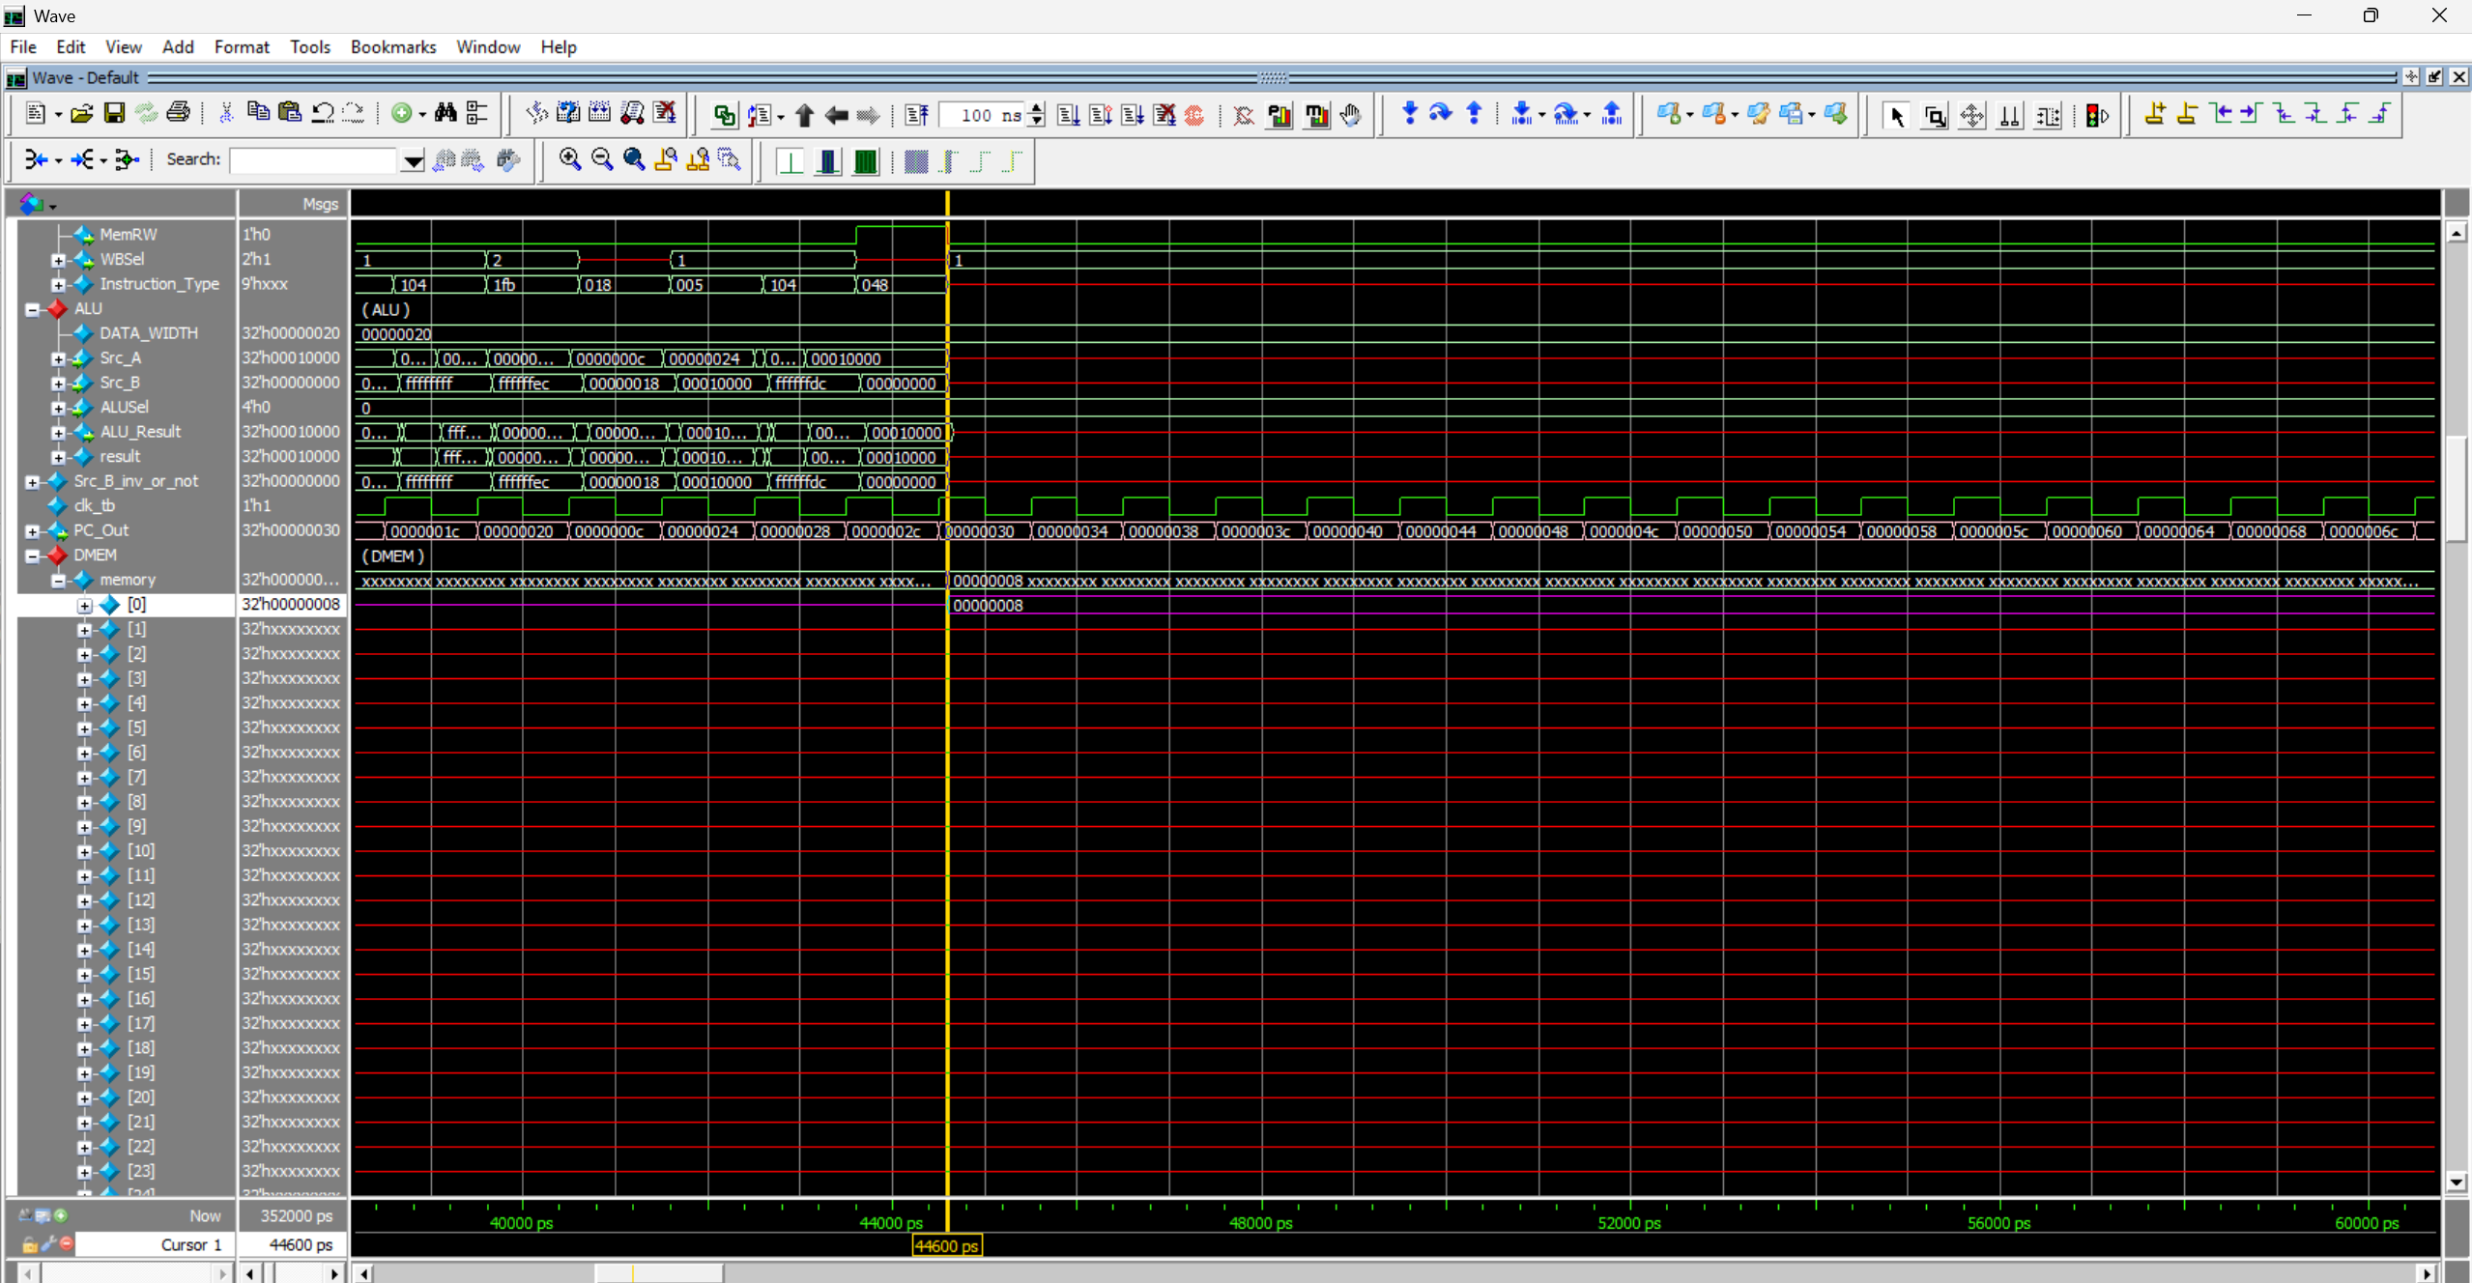

Figure ‎3‑3: 6th Fibonacci number successfully written at memory address 0.

# Pipelined RISC-V Archtiecture

To apply pipelining to RISC-V, we divide the datapath into five stages: Instruction Fetch (IF), Instruction Decode (ID), Execute (EX), Memory Access (M), and Write Back (WB), as shown in Figure ‎4‑1.

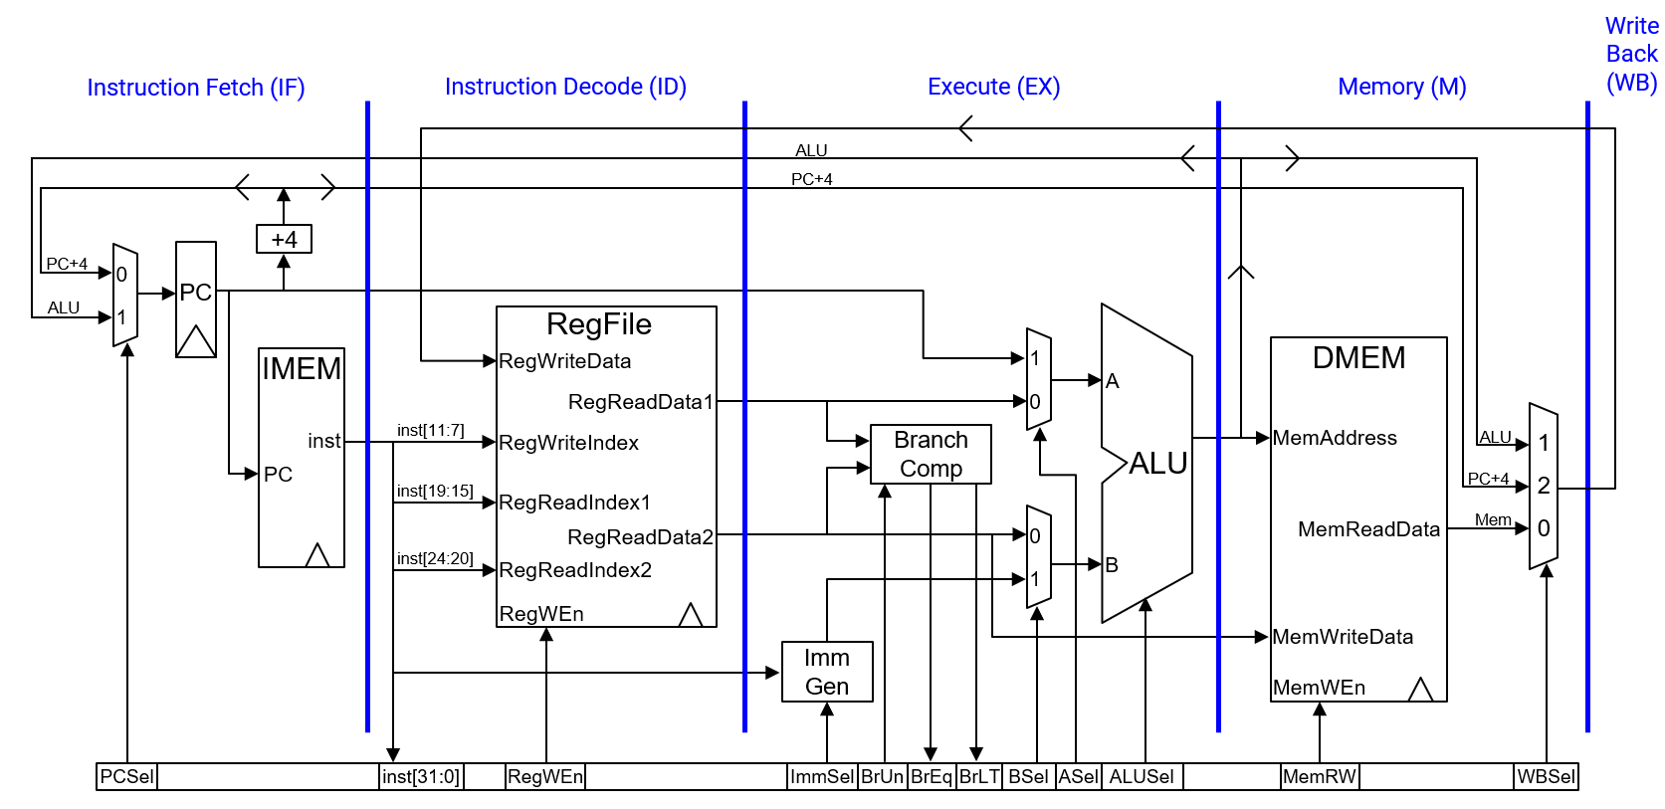

Figure ‎4‑1: Datapath divided into 5 stages. [2]

Add registers between each stage to hold signals until the next clock cycle, shown in Figure ‎4‑2.

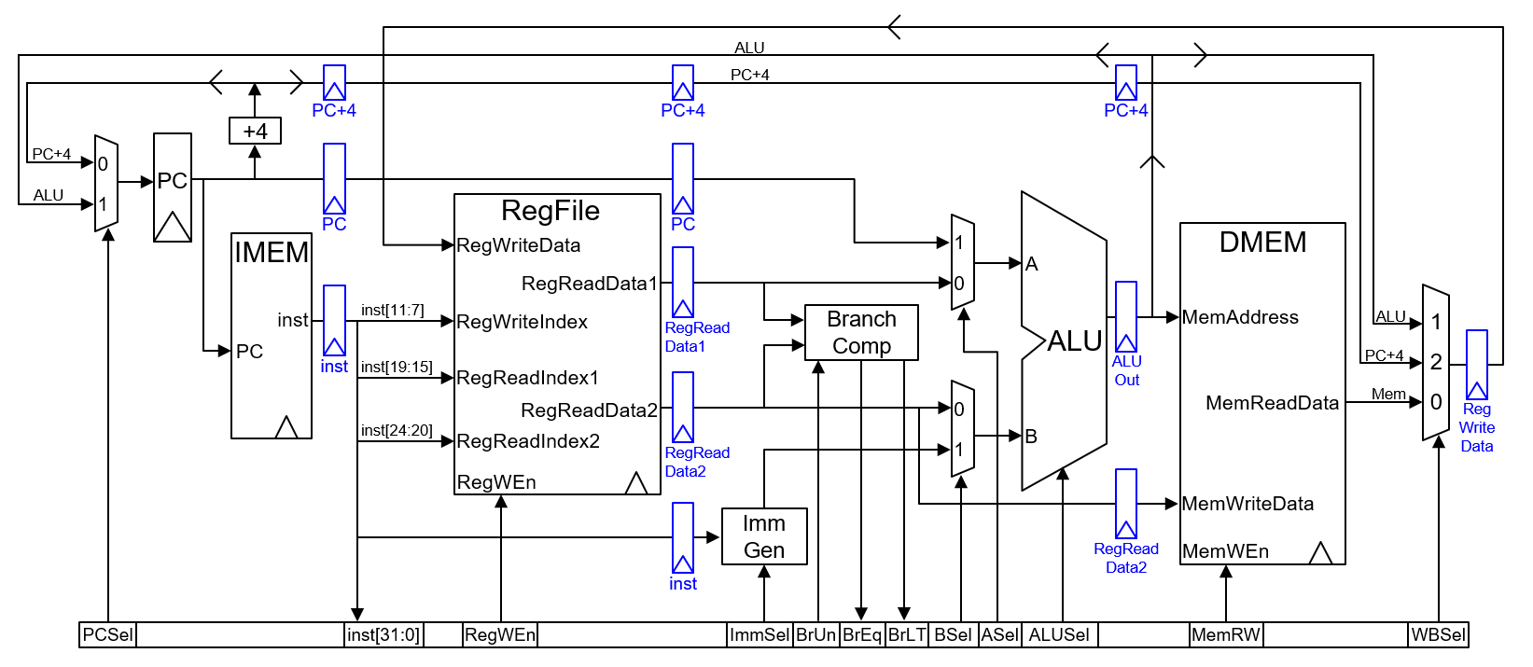

Figure ‎4‑2: Registers added between each stage. [2]

Recompute PC+4 from PC in the memory stage to avoid storing or passing both PC and PC+4 down the pipeline, shown in Figure ‎4‑3.

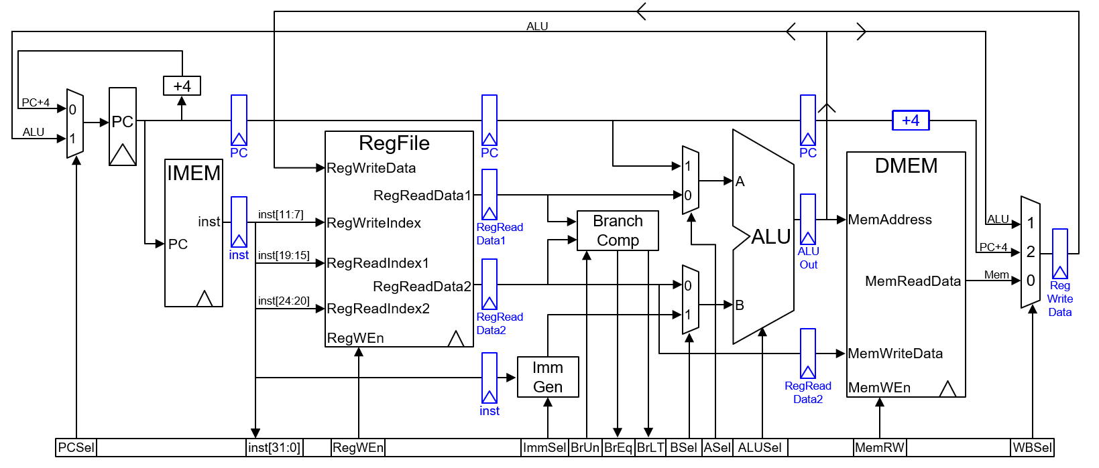

Figure ‎4‑3: Recomputing PC+4 in the memory stage. [2]

Additionally, update RegWriteIndex to use the rd field from the WB stage instruction instead of the ID stage instruction, shown in Figure ‎4‑4.

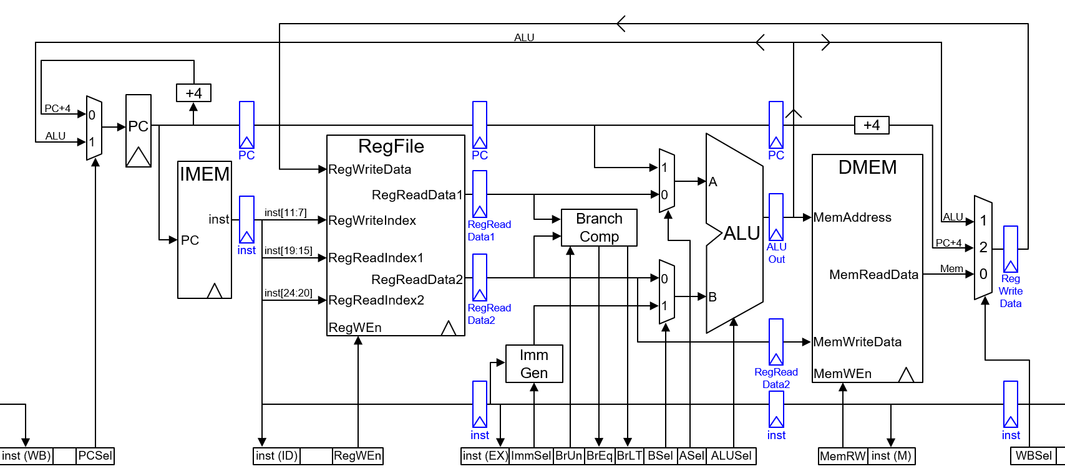

Figure ‎4‑4: Update RegWriteIndex to use the rd field from the WB stage. [2]

Now that the concept is clear, I implemented pipelined RISC-V based on the following final diagram with some modifications. I moved BrEq and BrLT from the execution stage to the memory stage, as they are responsible only for generating the PCSel signal, shown in Figure ‎4‑5. As a result, they needed to be registered to ensure they arrive at the right time for correct pipeline operation, as shown in the final version in Figure ‎4‑6.

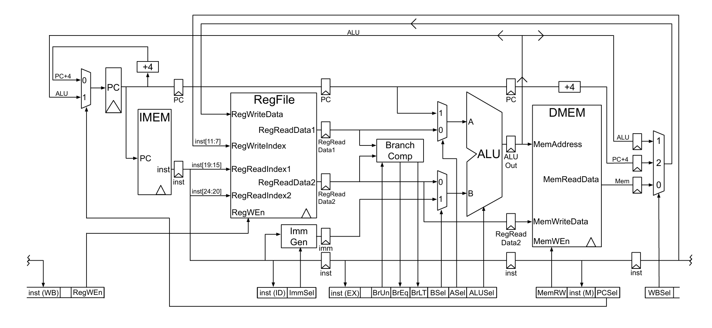



Figure ‎4‑5: Modified pipelined RISC-V architecture. Adapted from [3]

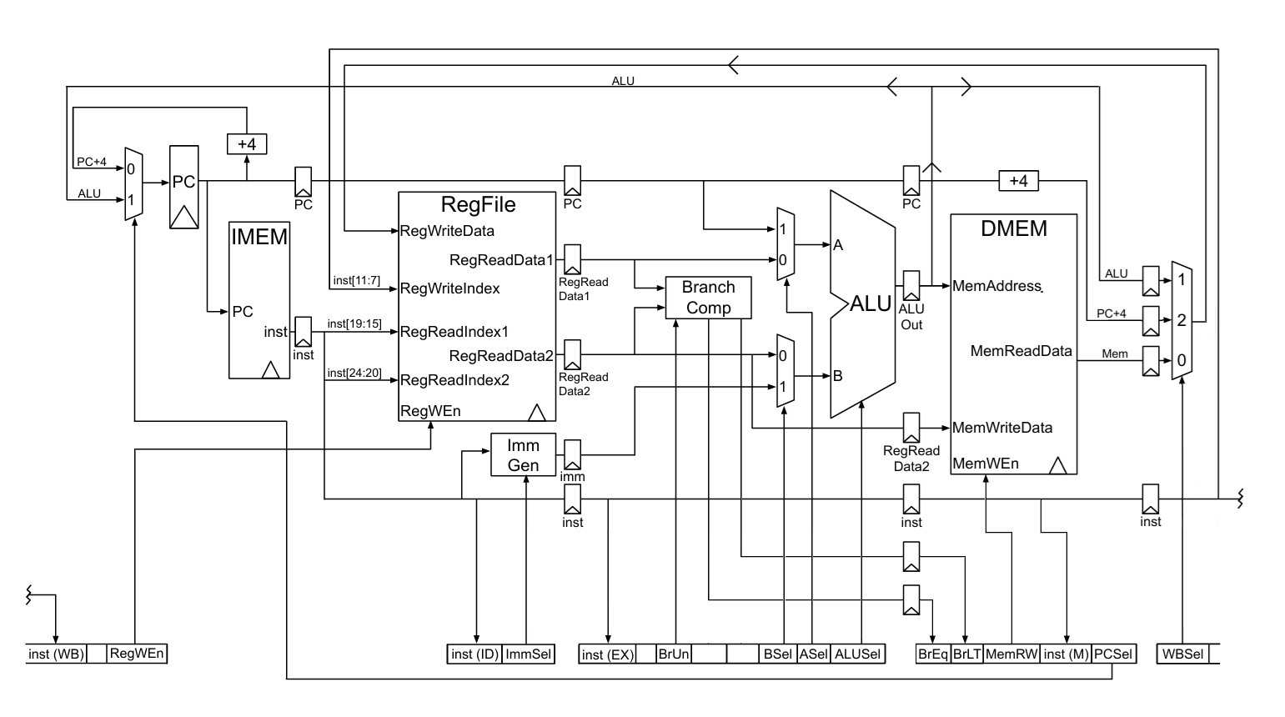

Figure ‎4‑6: Final pipelined RISC-V architecture. Adapted from [3]

The following Figure ‎4‑7 presents a summary of RISC-V instruction formats, categorizing them into R-type, I-type, S-type, B-type, U-type, and J-type, each with its specific bit-field structure.

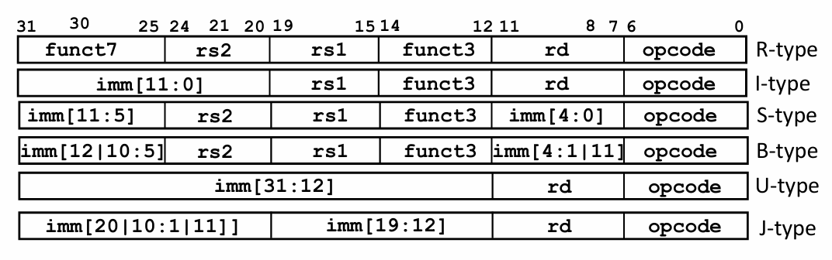

Figure ‎4‑7: Summary of RISC-V instruction formats. [4]

The below figure illustrates the general operation of the RISC-V pipeline, showing the flow of instructions through each of the five stages until the pipeline is fully filled.

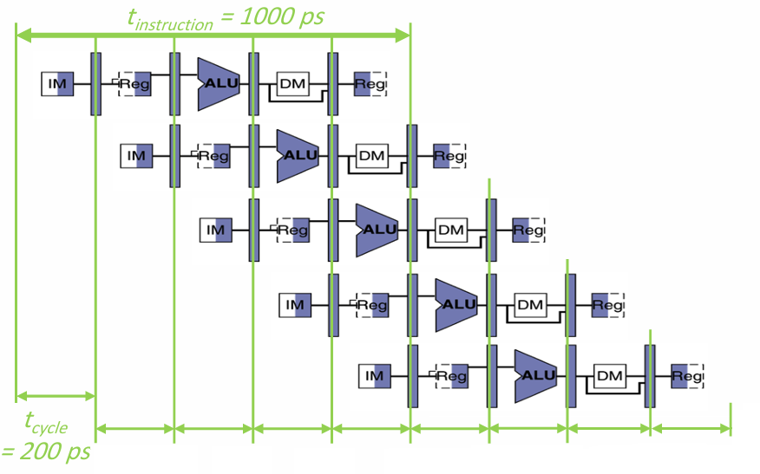

Figure ‎4‑8: Pipeline Stages of the RISC-V. Adapted from [5]

## Pipeline Hazards

### ****Data Hazards****

Data hazards arise when instructions that exhibit data dependencies are executed concurrently in the pipeline, causing conflicts.

#### **Types of Data Hazards:**

1. **RAW (Read After Write) R-type instructions:**
   * Occurs when an instruction depends on the result of a previous instruction that has not yet completed.
   * **Solution:** Forwarding, stalls.
2. **Load:**
   * Occurs when an instruction writes to a register that a previous instruction is still reading.
   * **Solution:** Reorder instructions, stalls.

### **Control Hazards**

Control hazards occur when the pipeline cannot determine the next instruction to fetch due to a branch or jump.

**Solution:** Branch prediction, delay slots, stalls.

### ****Structural Hazards****

Structural hazards occur when two or more instructions compete for the same hardware resource.

**Solution:** Add resources, stalls.

**NOTE:** In RISC-V architectures, **structural hazards are typically avoided** due to the design of the ISAs and microarchitecture, which emphasizes simplicity and regularity.

The following Figure ‎4‑9 illustrates a pipelined execution of RISC-V instructions, highlighting that read and write operations on the register file occur within the same clock cycle. By using the negative edge for writing and the positive edge for reading, structural hazards are avoided.

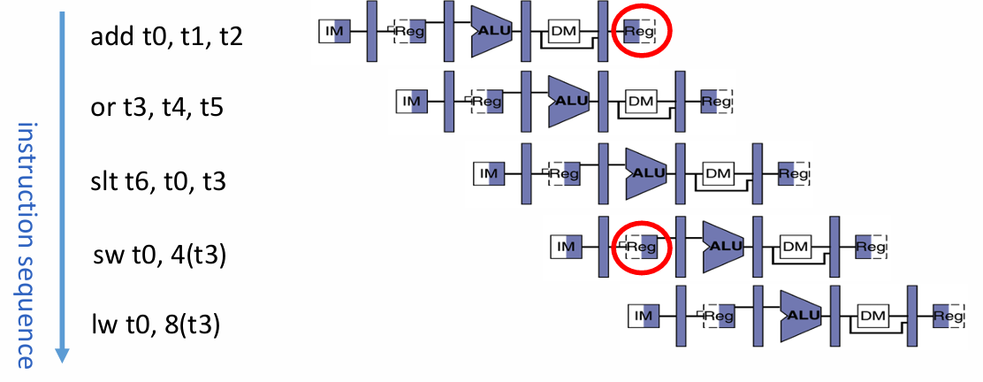

Figure ‎4‑9: Pipelined RISC-V instructions with edge-triggered memory access: write on negative edge, read on positive edge, eliminating structural hazards. [5]

**NOTE:** Writing and reading in the same cycle would not always be feasible, particularly in high-frequency designs.

## Implementation of Pipelined RISC-V Without Hazard Unit: Fixing Hazards by Stalling

**Instruction:** la t3, fib_result

* **Type of Hazard:** RAW Data Hazard

The pseudo-instruction la t3, fib_result (load address) is translated into two machine instructions in RISC-V assembly:

1. **First instruction:** auipc (add upper immediate to PC), which computes the upper part of the address relative to the program counter.
2. **Second instruction:** addi (add immediate), which computes the lower part of the address and completes the effective address computation.

After the auipc instruction, the pipeline needs two stalls (nops) to ensure the result is ready before the addi instruction uses it.

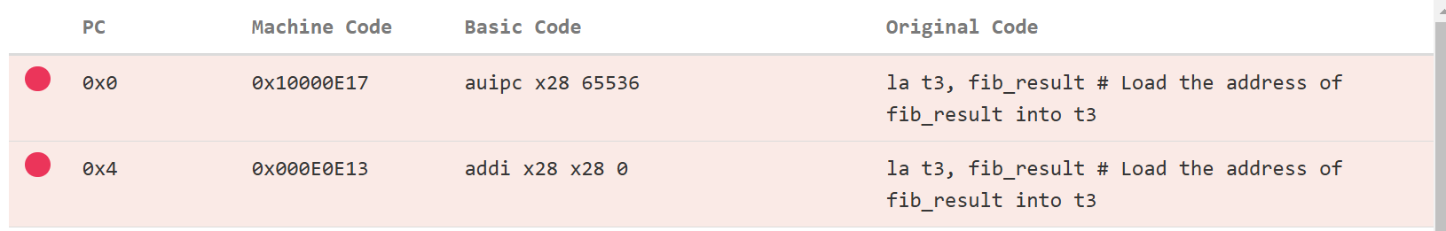

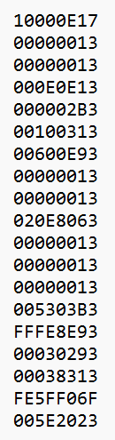

**Instruction:** mv t1, t2

* **Type of Hazard:** RAW (Read After Write) Data Hazard
  + The mv t1, t2 instruction depends on the result of the add t2, t1, t0 operation. Since t2 is written by the add instruction, the pipeline requires **1 stall** (nop) to ensure that t2 is fully updated before being copied to t1.
  + The optimal solution is to rearrange the instructions, where possible, by moving addi t4, t4, -1 after add t2, t1, t0 to minimize latency.

**Instruction:** beq t4, x0, finish

* **Type of Hazard:** Control Hazard (also includes RAW hazard)
  + If the branch is taken, or if there's a jump: The next three instructions in the pipeline are incorrect. This creates a control hazard! To resolve this, we need to convert the incorrect instructions in the pipeline to nops. This process is called flushing the pipeline.

Now after adding all the required stalls here and rearrangements the following is the full assembly code for pipelined RISC-V without hazard unit as shown in Figure ‎4‑10.

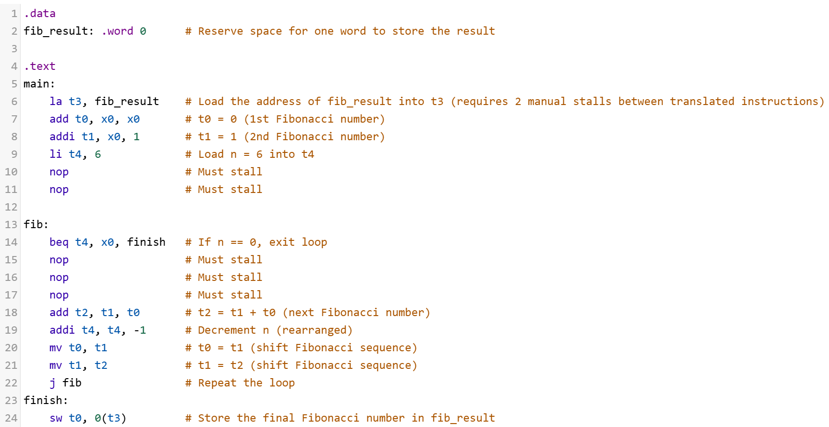

Figure ‎4‑10: Fibonacci Sequence for Pipelined RISC-V without Hazard Unit.

**NOTE**: 3 nops were added after branching instruction because we did not optimistically assume that the branch would not be taken. As a result, three cycles were required to generate the PCSel signal.

## Simulation Results with Stalling

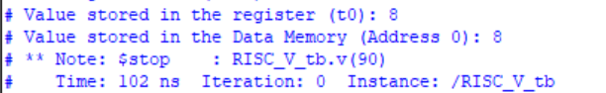

## Implementation of Pipelined RISC-V With Hazard Unit

### Handling Data Hazards via Forwarding

The forwarding logic in the hazard unit detects data hazards and selects the correct value from later pipeline stages to resolve dependencies. I modified it to consider the instruction instM in the third stage as shown in Figure ‎4‑11, ensuring proper forwarding since hazards can occur across three consecutive instruction. The same applies to the rs2 multiplexer, where forwarding is required to ensure the correct value is used.

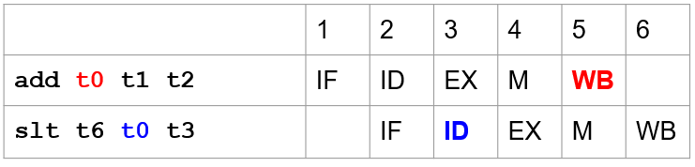

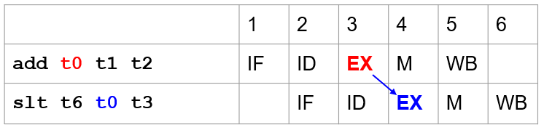

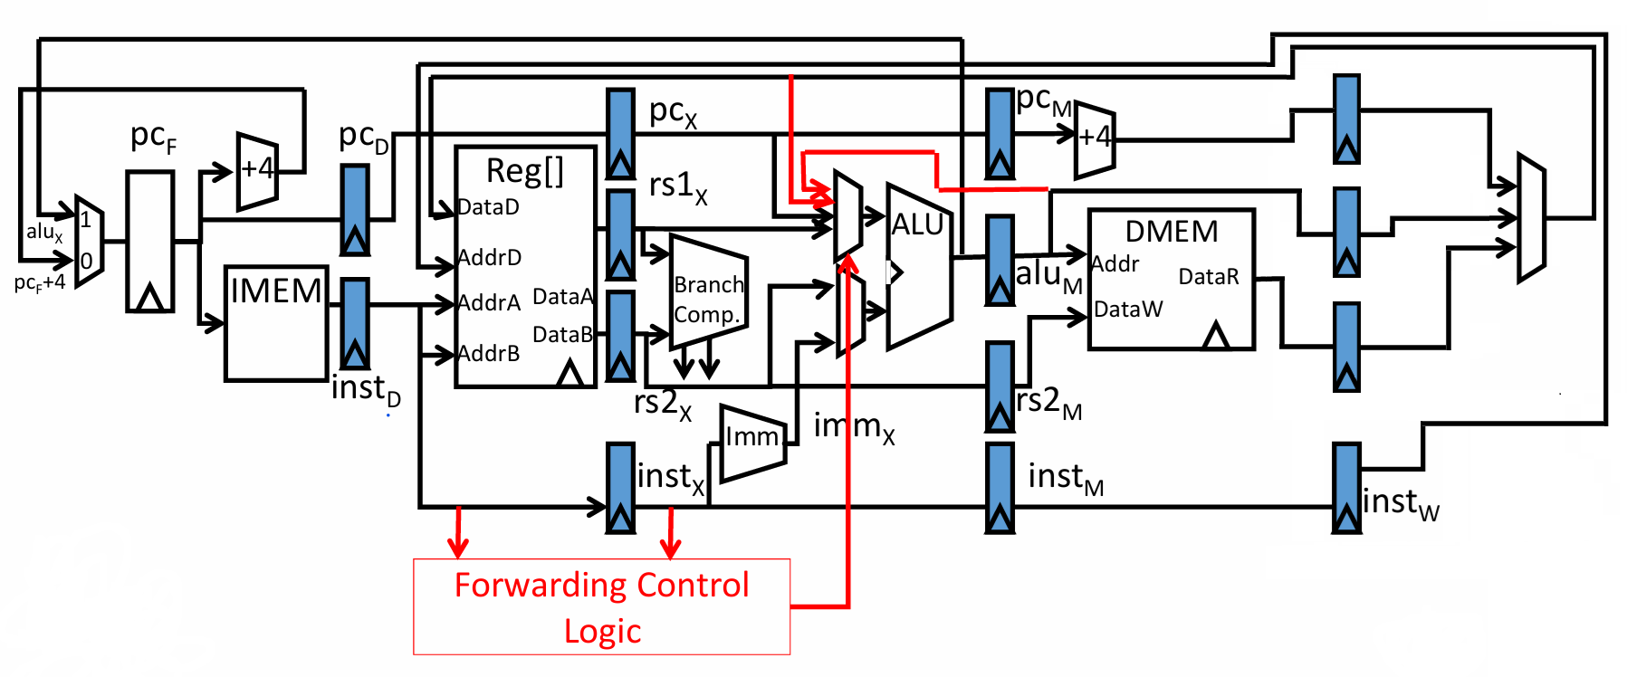

Figure ‎4‑11: Forwarding control logic in hazard unit. Adapted from [5]

I then separated the hazard multiplexer and created an independent one from the original datapath, placing it right after the pipelined DataA and DataB. This allows the new value to be used in both the ALU and the branch comparator, as shown in Figure ‎4‑12.

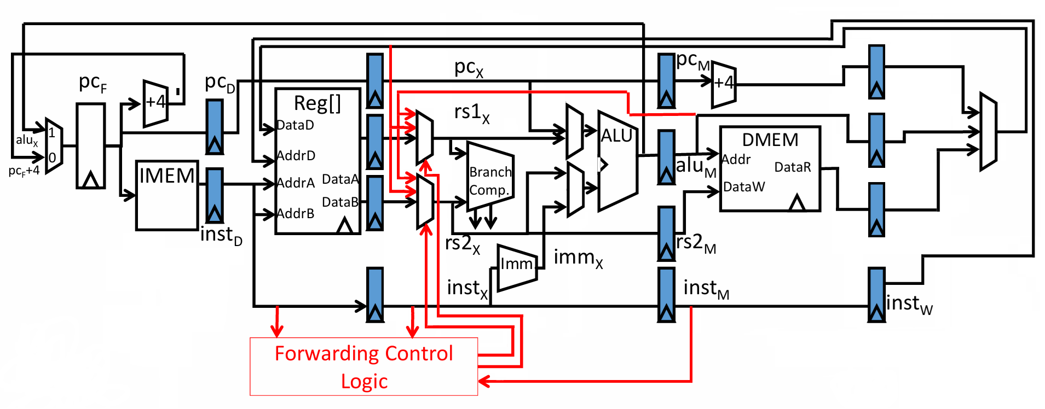

Figure ‎4‑12: Updated forwarding logic ensuring correct data propagation across pipeline stages. Adapted from [5]

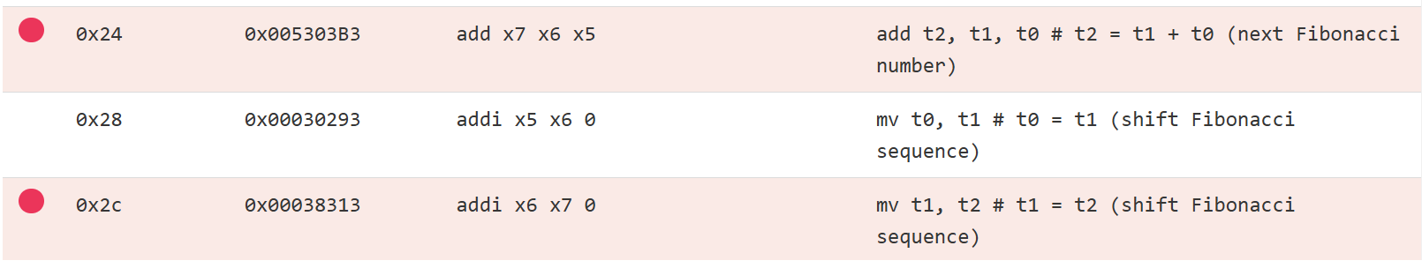

Here we can see that there is data hazard where the destination register x7 (rd) will be read in the 3rd instruction as source register (rs1) so we will need to take the value from the write back stage back to the ALU to perform the addition, as shown in Figure ‎4‑13 and Figure ‎4‑14. This is why instM needed to be added to the forwarding condition, ensuring correct data dependency resolution.

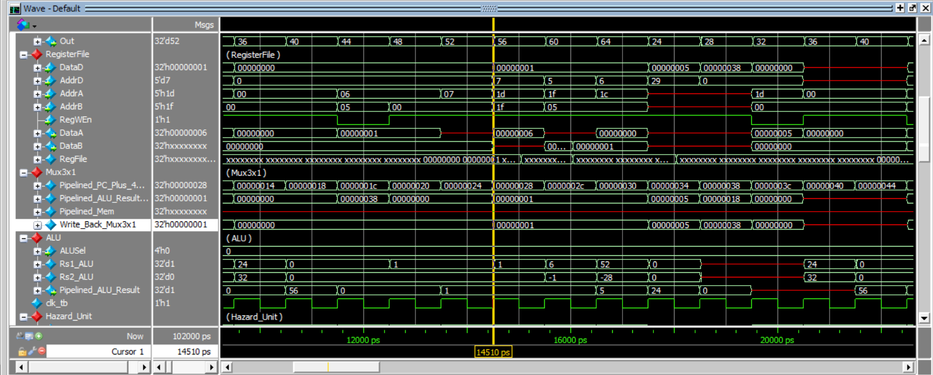

Figure ‎4‑13: ALU result from the previous instruction is available at the write back multiplexer.

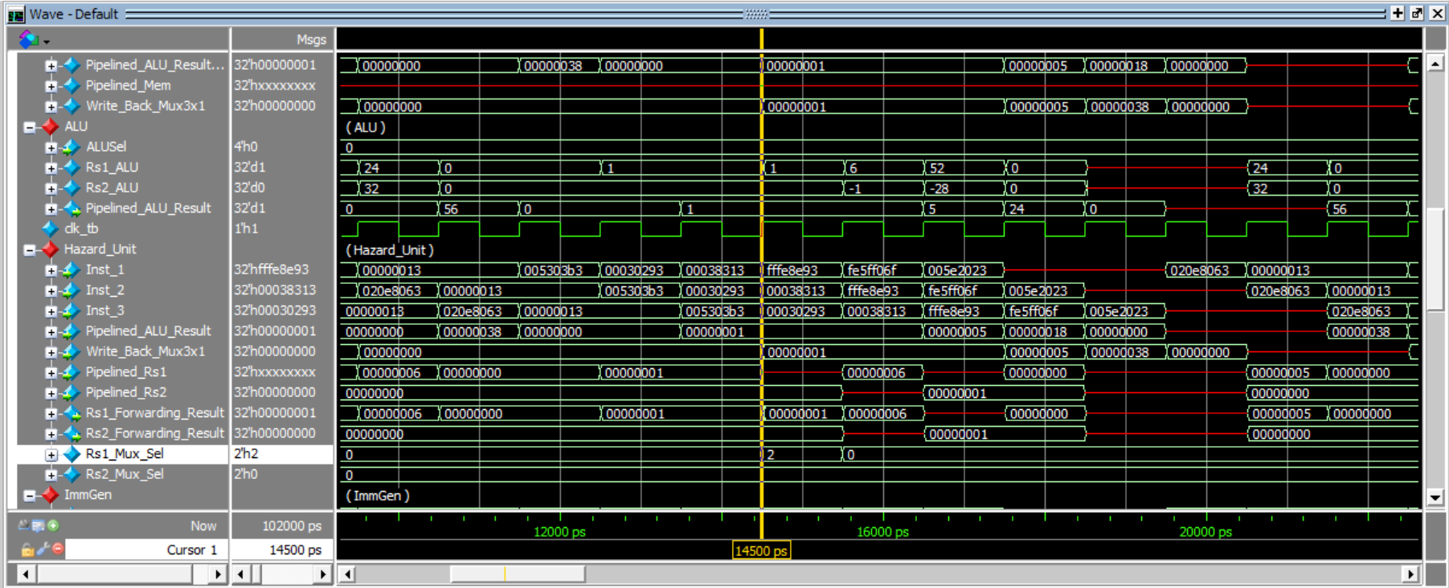

Figure ‎4‑14: Hazard multiplexer for rs1 set to 2, selecting the value from the write back stage.

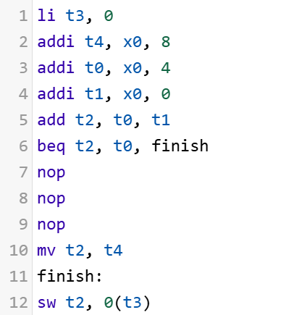



Here, we can see why it was crucial to place the 3-to-1 multiplexer immediately after the pipeline register output of the register file. This ensures that the computed value of t2 from the addition instruction is available for the next instruction, allowing it to be correctly read by the branch comparator, thereby resolving the data hazard as shown in Figure ‎4‑15 and Figure ‎4‑16.

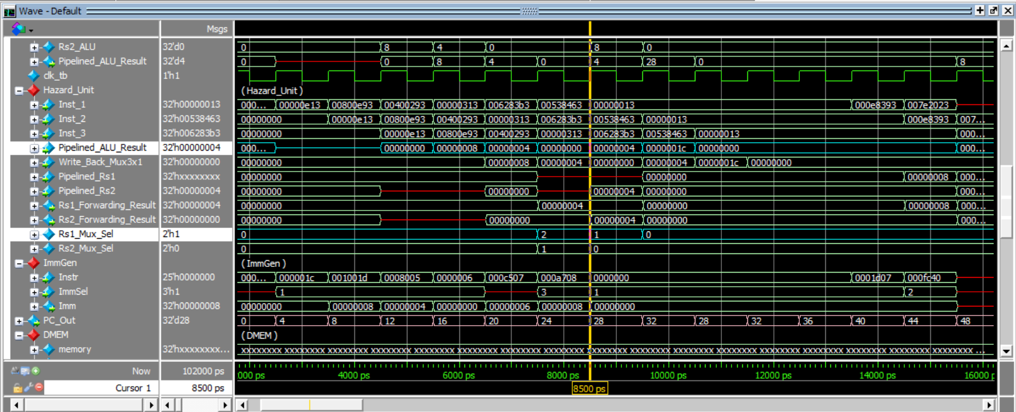

Figure ‎4‑15: ALU result forwarded to the branch comparator for Rs1.

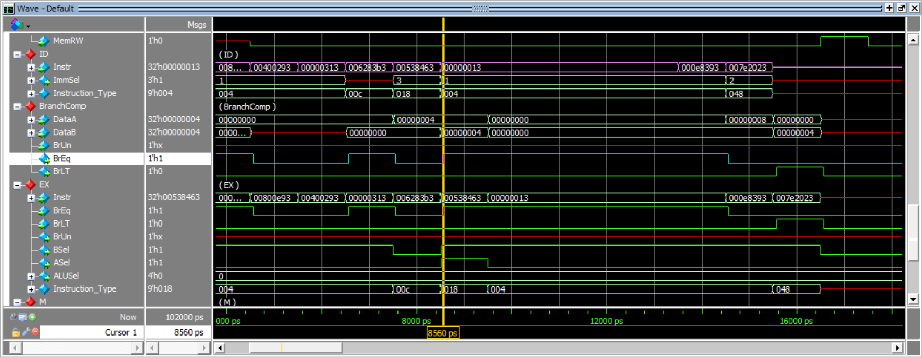

beq instruction

Rs1 forwarded from ALU

Figure ‎4‑16: Successful forwarding of Rs1.

### Resolving Load Hazards

In the lw (load word) instruction, there is an unavoidable stall due to the need for the data to be loaded from memory before it can be used by the subsequent instruction. This stall occurs because the data is not available immediately after the load instruction executes; it requires an additional clock cycle for the data to reach the memory stage and be forwarded to the ALU or registers, delaying the next instruction, as shown below [6].

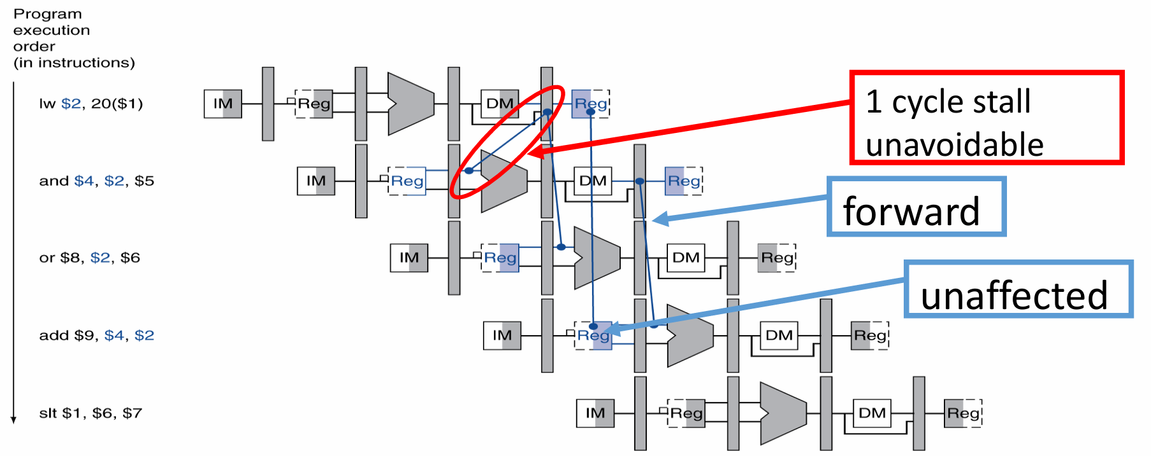

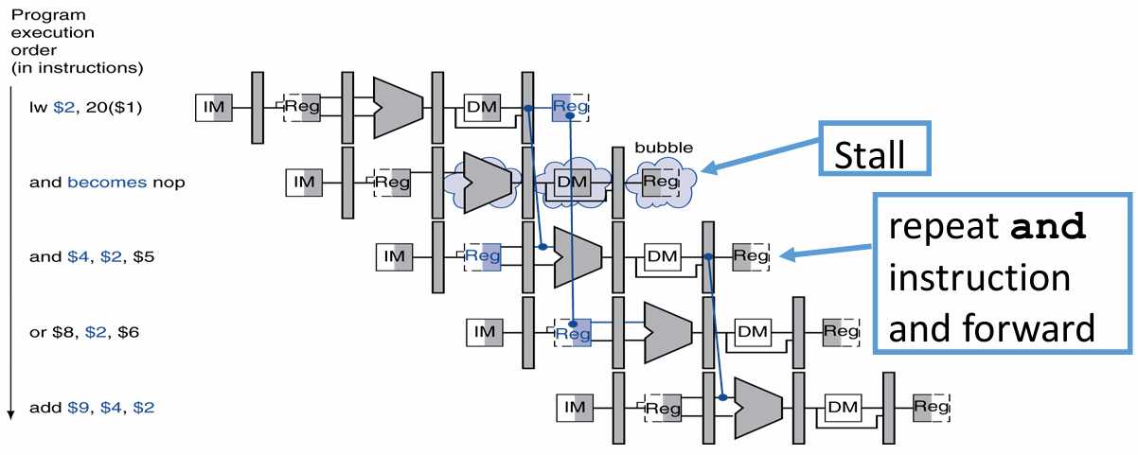

A load hazard is resolved by detecting a load instruction (e.g., lw) followed by a dependent instruction. In load hazard control, both the PC and instruction registers are disabled to hold their previous values for one clock cycle, effectively stalling the pipeline, as shown in Figure ‎4‑17. This allows the load instruction to complete before the dependent instruction is executed, as shown in Figure ‎4‑18.

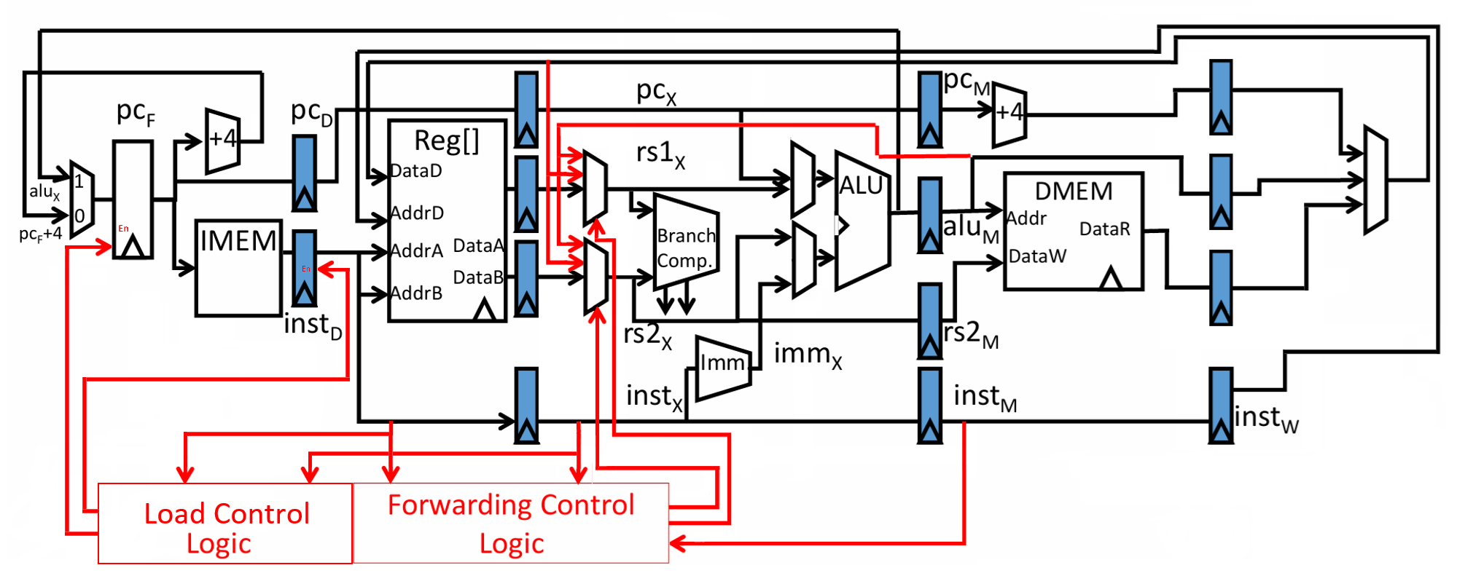

Figure ‎4‑17: Load hazard control: stalling the PC and instruction registers to resolve data dependencies. Adapted from [5]

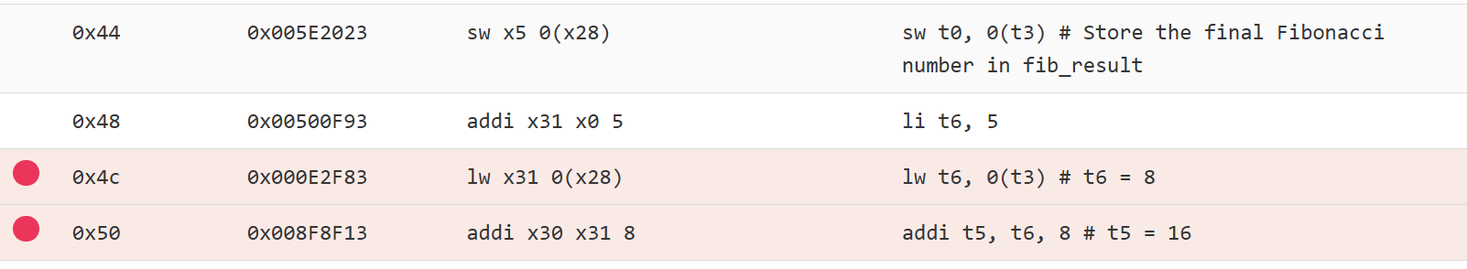

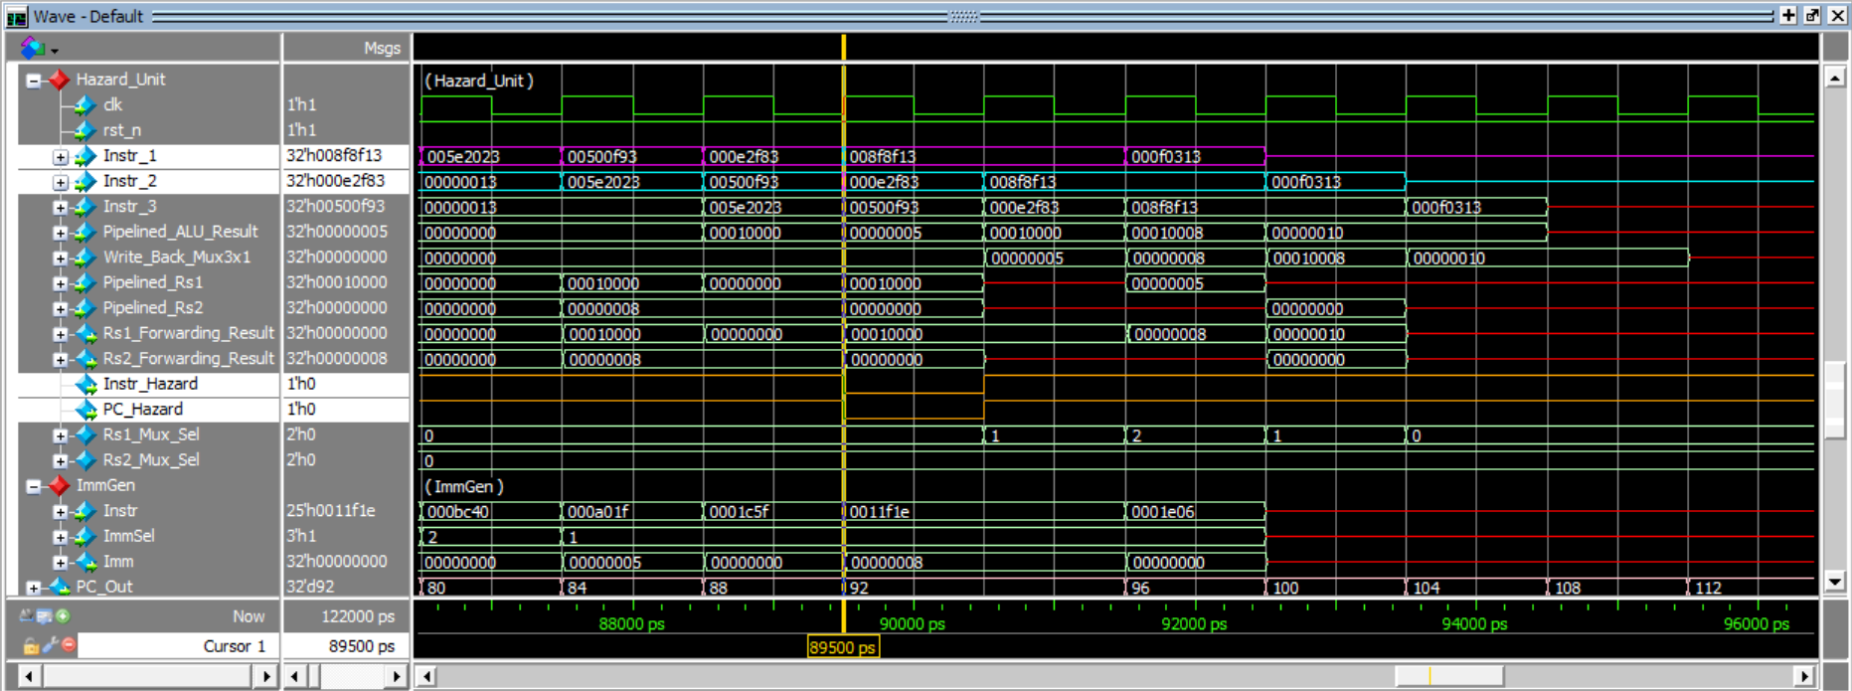

Figure ‎4‑18: Handling load hazards.

## Modified RTL for Pipelined RISC-V

### Enabled Register

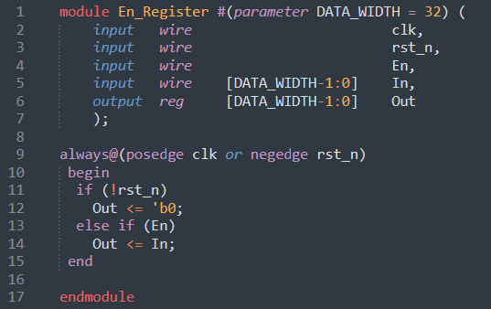

### PC

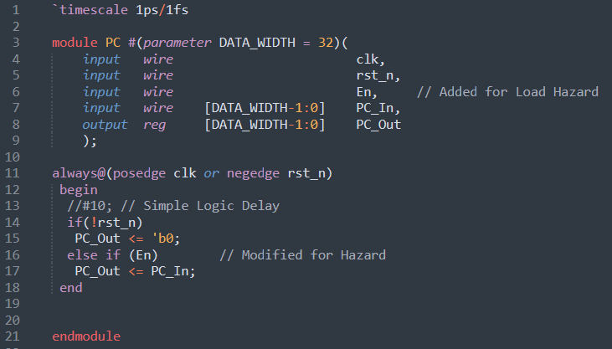

### Datapath

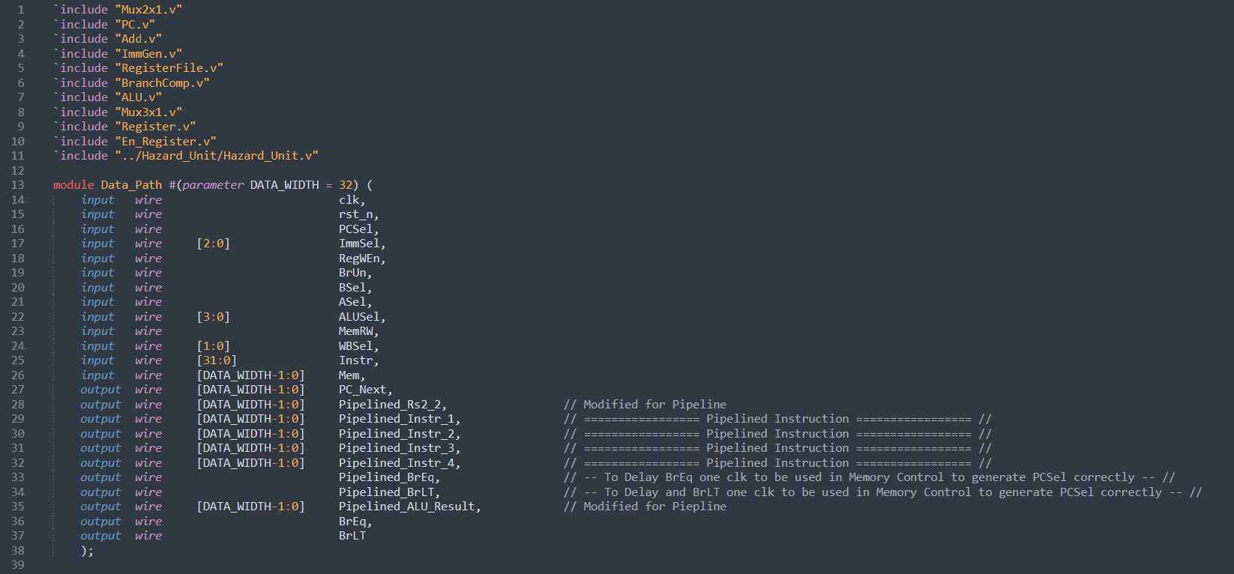

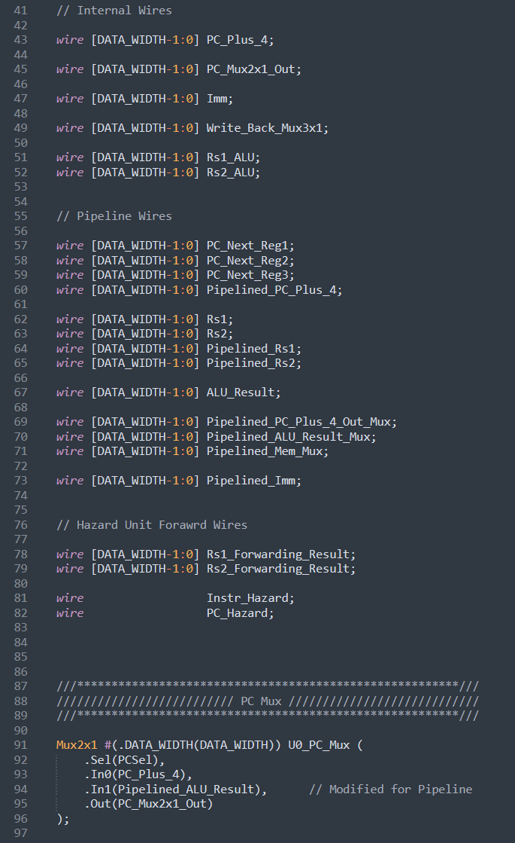

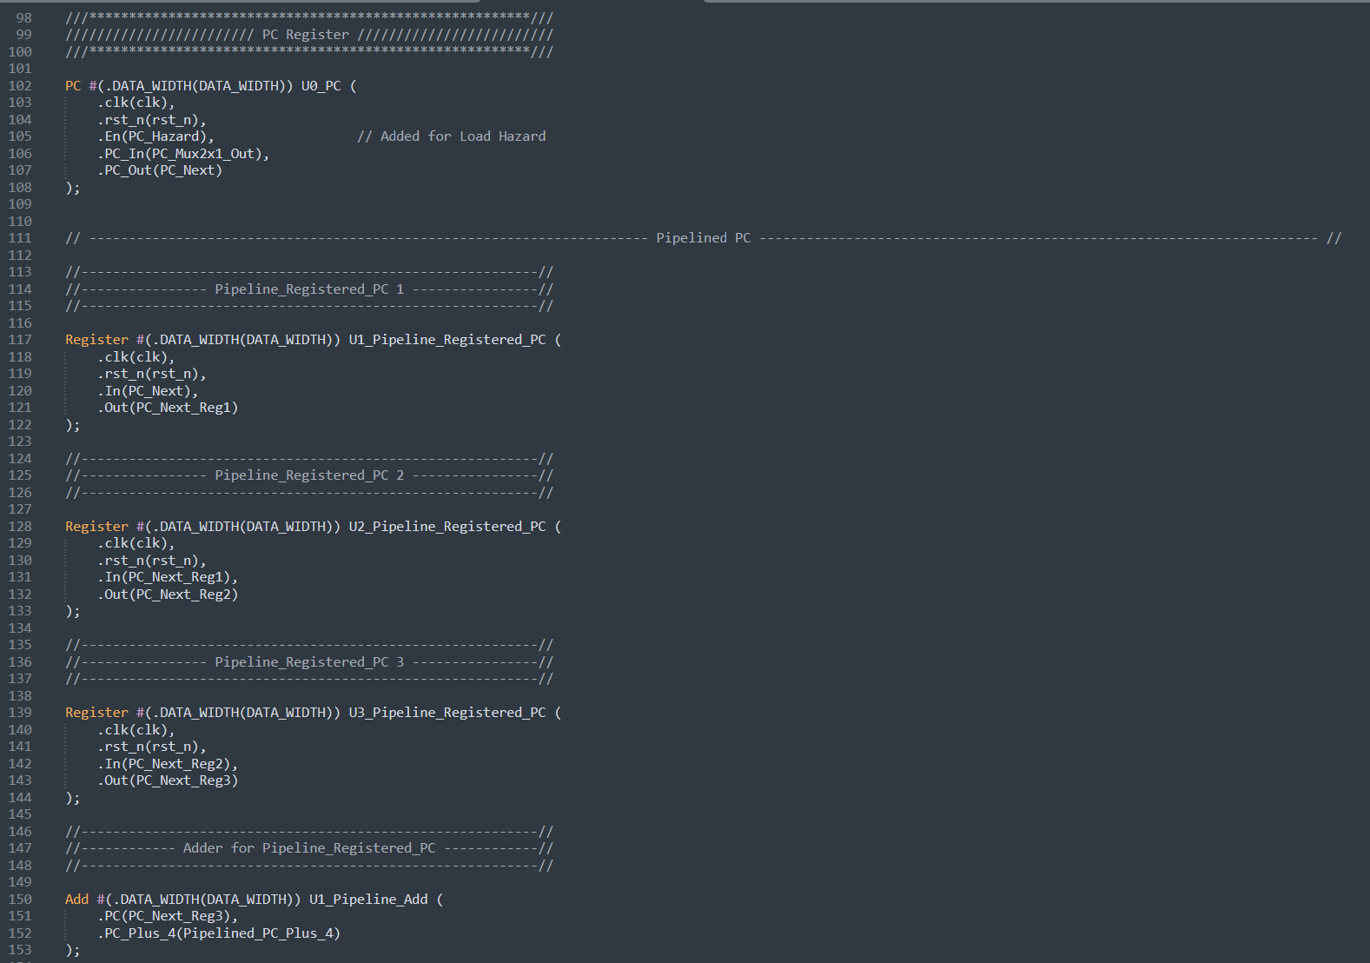

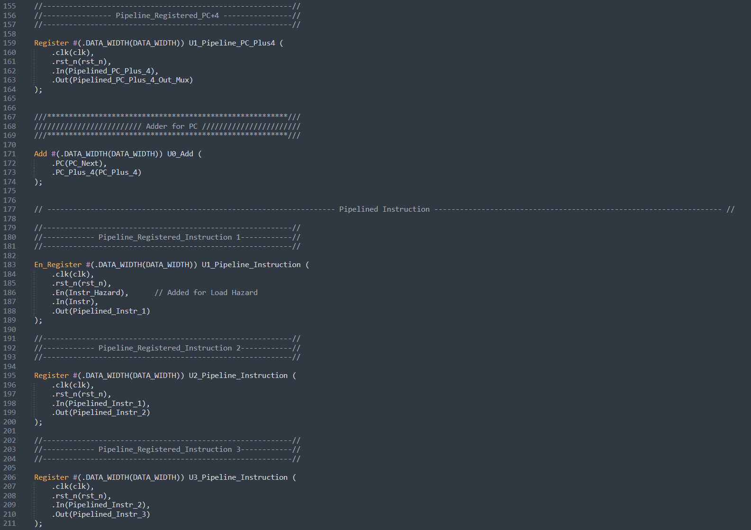

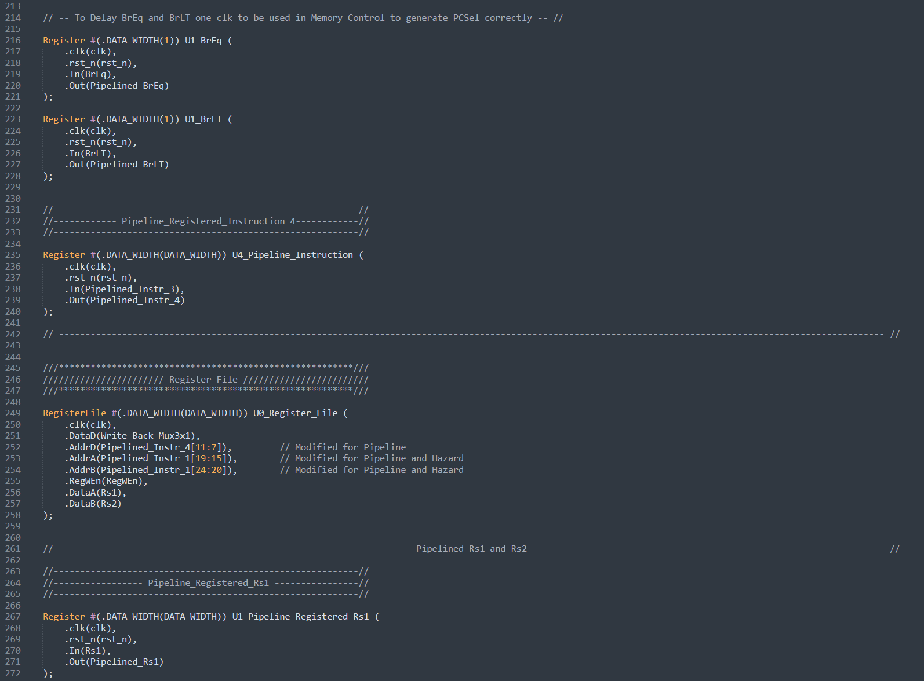

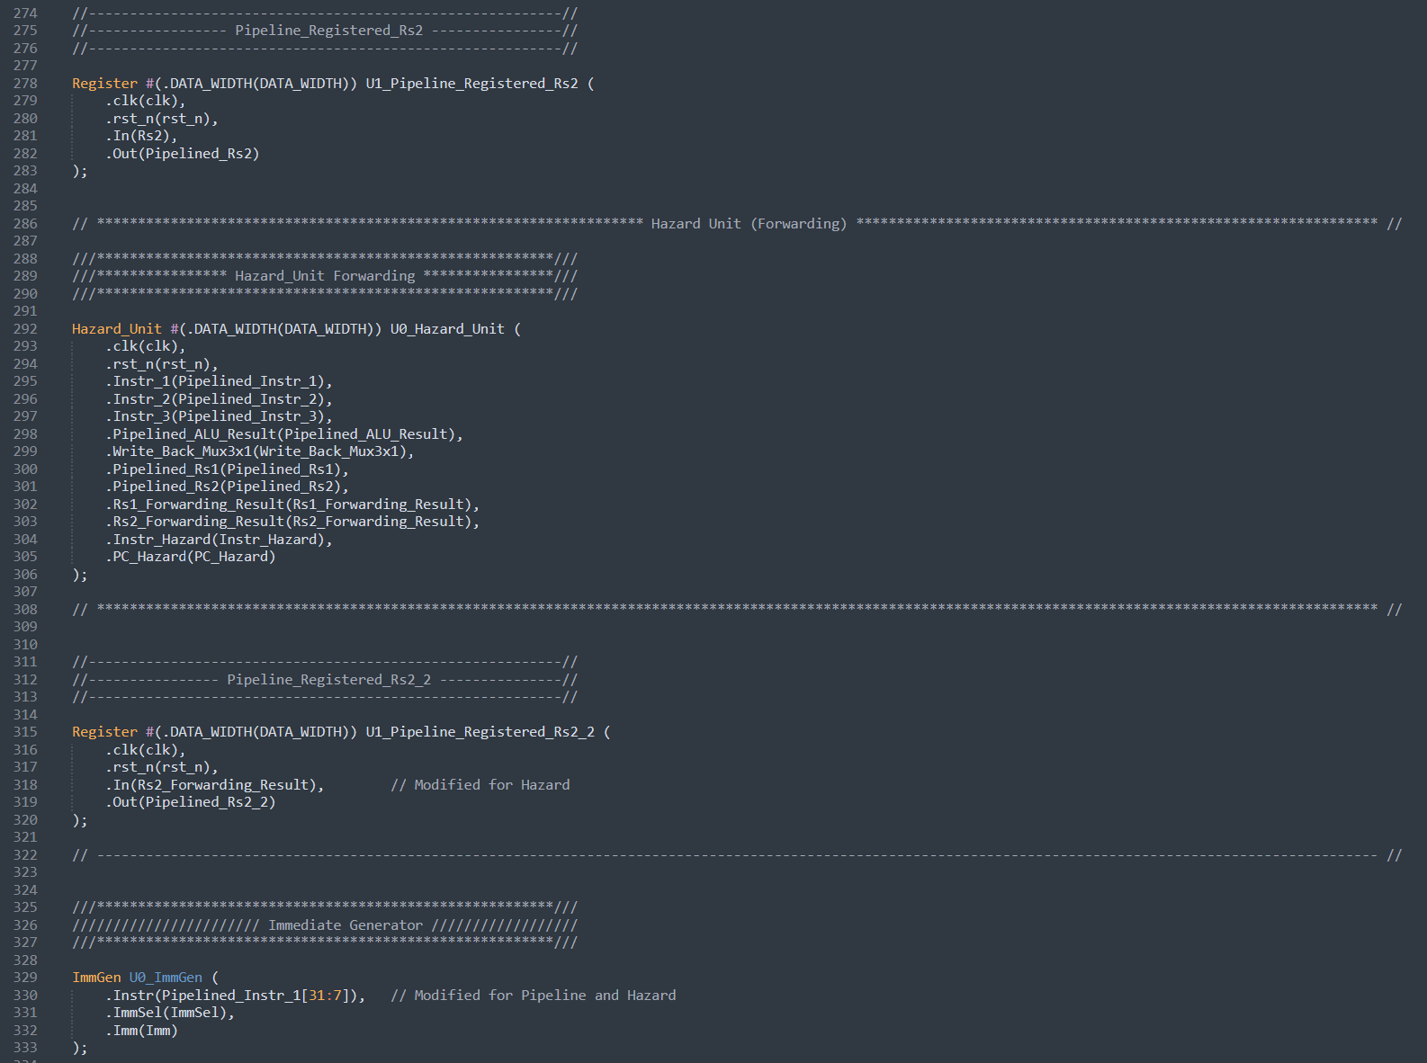

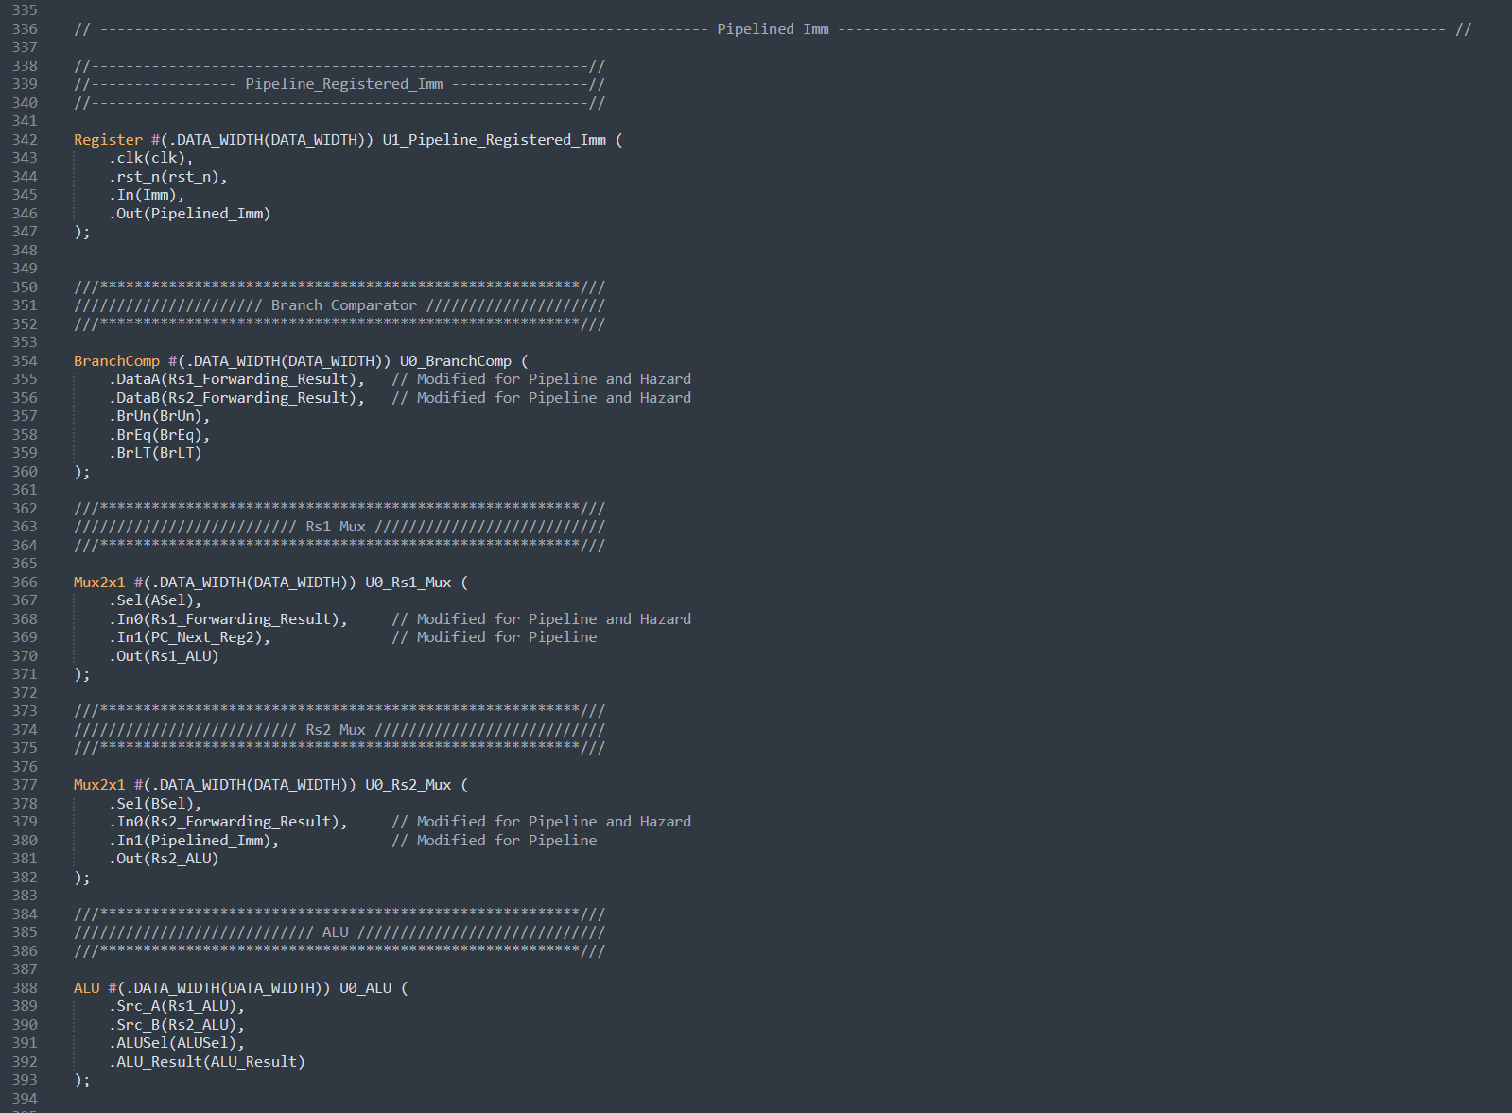

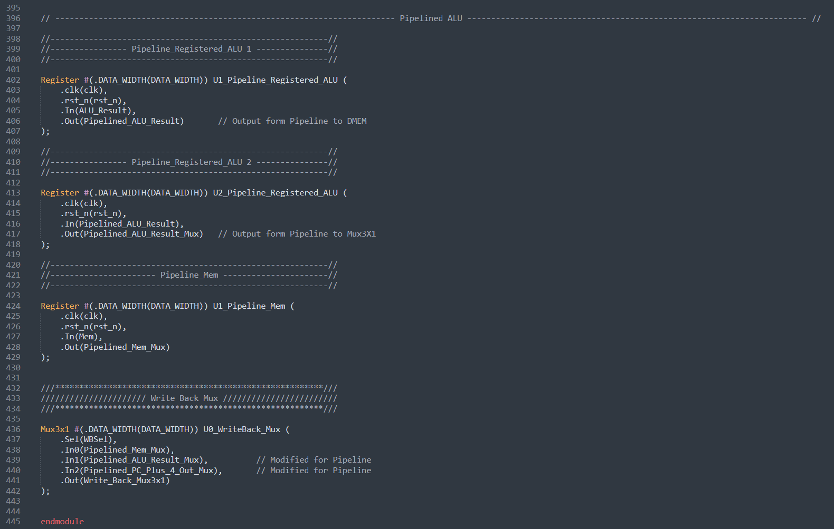

### Control Logic

The control logic in the pipelined RISC-V design is divided into five stages, with each stage mirroring the conditions of a single-cycle design. However, in the pipelined version, each stage only generates the output signals for its respective stage. These stages are:

1. Control_Logic_Decode
2. Control_Logic_Execute
3. Control_Logic_Memory
4. Control_Logic_Write.

### Hazard Unit

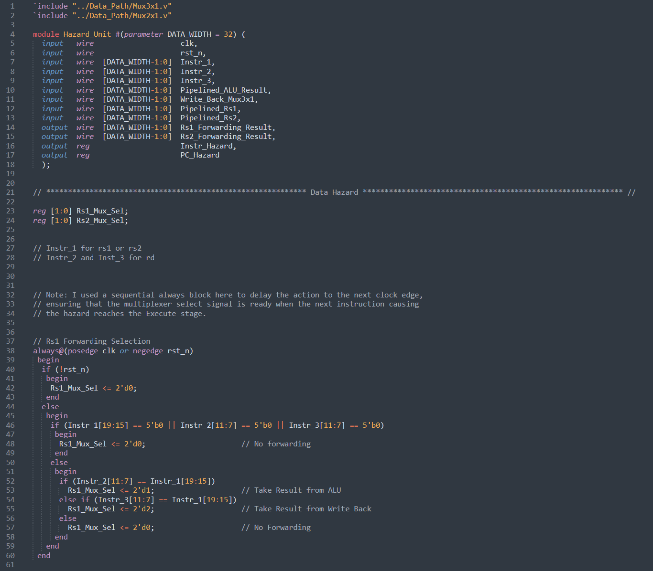

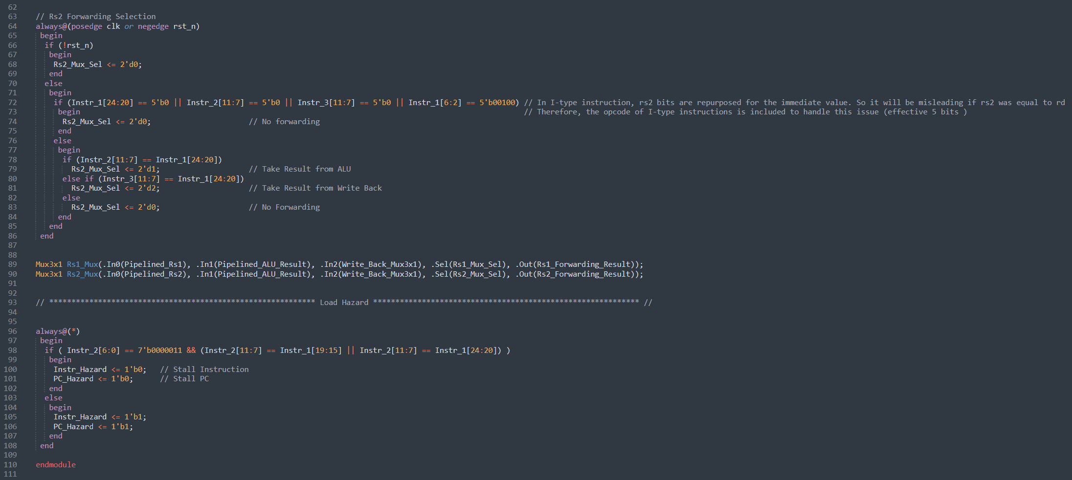

## Simulation Results of Pipelined RISC-V with Hazard Unit

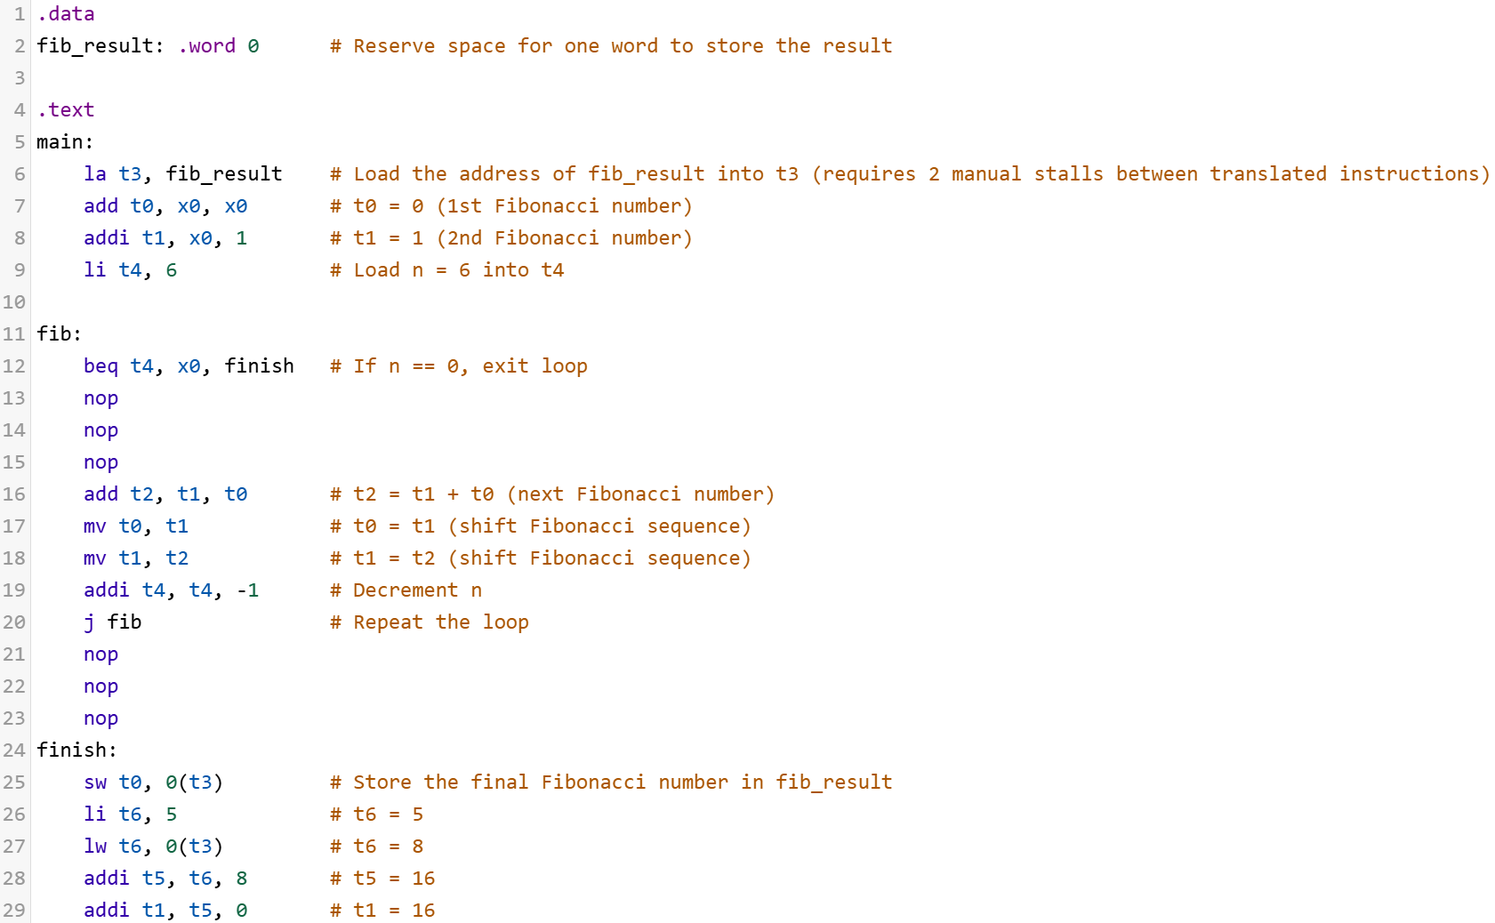

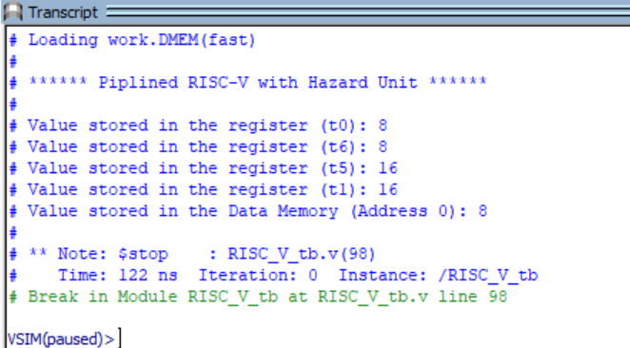

# References

[1] N. Garcia and B. Nikolić, CS61C: Datapath II, Lecture 30, University of California, Berkeley, Fall 2018.

[2] Dan Garcia, Bora Nikolić, and Peyrin Kao, CS61C: Pipelining, Lectures 21–22, University of California, Berkeley, Fall 2024.

[3] “reference-card.pdf.” Accessed: Jan. 29, 2025. [Online]. Available: <https://cs61c.org/sp25/pdfs/resources/reference-card.pdf>

[4] N. Garcia and B. Nikolić, CS61C: RISC-V Formats II, Lecture 11, University of California, Berkeley, Fall 2018.

[5] N. Garcia and B. Nikolić, CS61C: Machine Structures, Lecture 32 – Pipeline II, University of California, Berkeley, Fall 2018.

[6] N. Garcia and B. Nikolić, CS61C: Machine Structures, Lecture 32 – Pipeline III, University of California, Berkeley, Fall 2018.

[7] D. Harris and S. Harris, Digital Design and Computer Architecture: RISC-V Edition, 2nd ed., Burlington, MA: Morgan Kaufmann, 2021.